ZENTANGLES

“The Zentangle Method is an easy-to-learn, relaxing, and fun way to create beautiful images by drawing structured patterns.” www.zentangle.com

Zentangles are intricate drawings of patterned line, created with a black pen and paper. The process is meant to be artistic, intuitive, relaxing, focussed, detailed and meditative. The results are meant to be elaborate and resemble doodling.

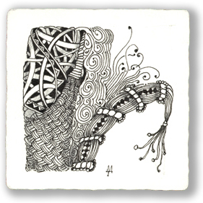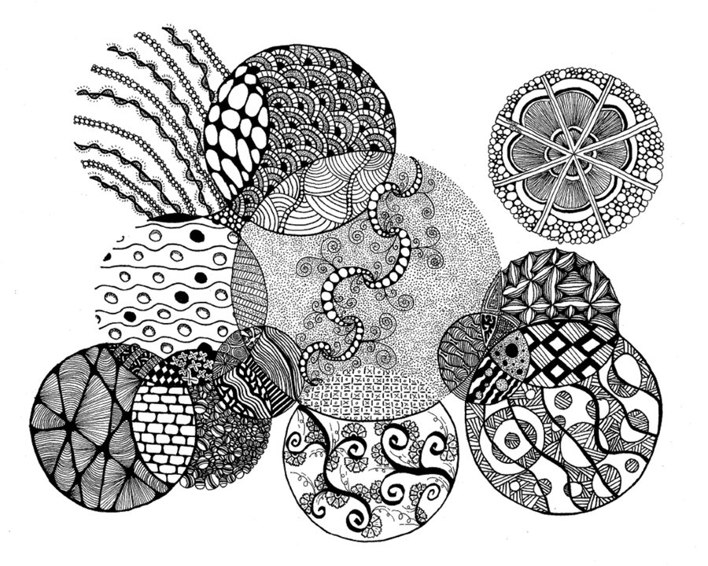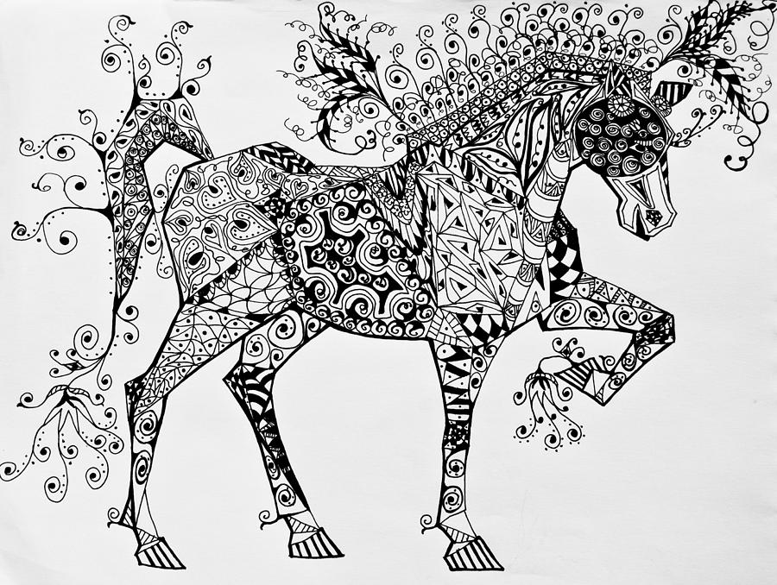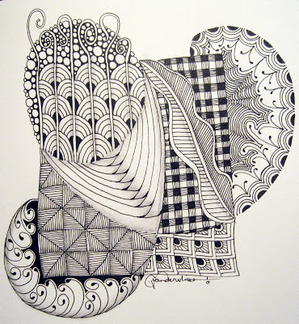

ZENTANGLE PATTERN EXAMPLES
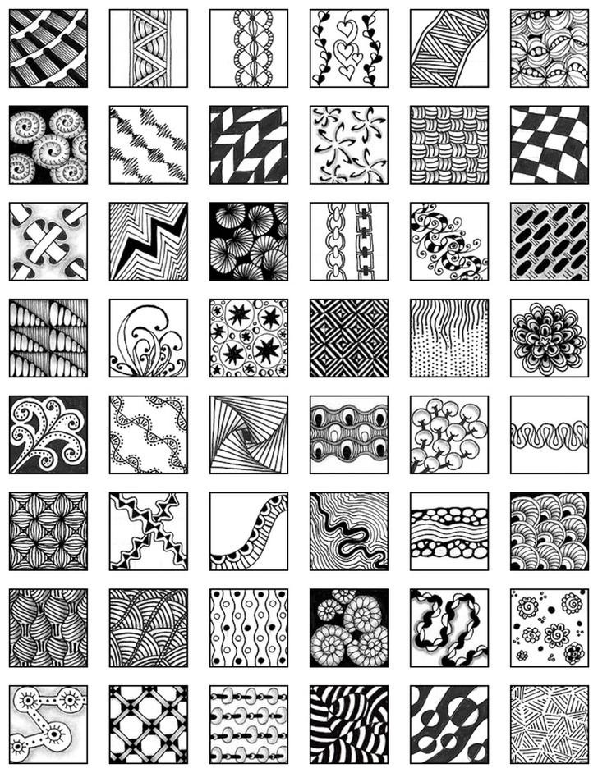

NOW YOU TRY CREATING YOUR OWN DESIGNS

