ZENTANGLE ASSIGNMENT

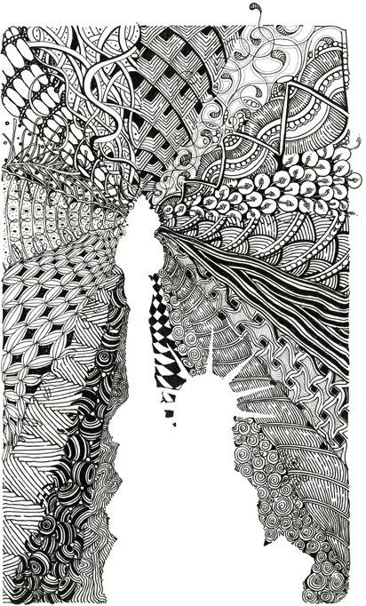
Each student will create their own negative space image, surrounded by Zentangle on an 8.5x11 sheet of paper using a fine point black marker.

Step 1: Choose an inspirational word from the list provided – your entire artwork will be based on this concept: your central image, the quality of your lines, the patterns you create…

Step 2: Brainstorm 3 possible disigns in your sketchbook (or on a blank piece of paper) with thumbnail sketches. Each idea must have a different central image, a different template for arranging your varrying zentangles, and different qualities of line.

Step 3: Conference with me! Then, Choose one of the designs from your sketchbook to create as your good copy, in full size.

Step 4: Plan out several small scale thumnails (at least 10) of zendoodle patterns you will use in your final drawing. The lines you use and the patterns you create should create a tone/mood that suits your central image. *some may be found doodles, others will be your own designs.

Step 5: Trace and cut out a silhouette of your central image. Carefully tape it to your 8.5x11 white piece of paper.

Step 6: Zendoodle around/across your cut-out, filling the white space on your sheet.

Step 7: Remove your cut-out to see your final work.

Inspirational words: hope, fear, love, pain, memory, aspirations, power, weakness
AVI 2OX Negative Space Zentangle Assignment Rubric Name:
Criteria: Level R = none-insufficient Level 1 = limited Level 2 = somewhat Level 3 = considerably Level 4 = thoroughly
(50 - 59%) (60 - 69%) (70 - 79%) (80 - 100%)
Knowledge and Understanding (Understanding of concepts, elements, principles, meaning and significance)

• Student has demonstrated an understanding of shape and used it in a variety of ways  • Student has demonstrated an understanding of line and used it in a variety of ways  • Student has demonstrated an understanding of pattern and used it in a variety of ways  • Student has demonstrated an understanding of positive/negative space | R 1 2 3 4  R 1 2 3 4  R 1 2 3 4  R 1 2 3 4 | overall mark for category:  /40

Thinking and Inquiry (Planning & Process; Creative thinking skills & processes, critical analysis)

Planning & Process  • evidence of thorough brain–storming, research notes, preliminary planning, reference material; documented (in sketchbook/binder/folder) (3 rough ideas)  • Student has conference with me, on time, and taken suggestions into consideration | R 1 2 3 4  R 1 2 3 4 | overall mark for category:  /20

Communication (The conveying of meaning through various forms; communication of intended message expression/organization of ideas)

The completed rubric answers:  • The rubric questions have been thoroughly answered and were properly submitted with your completed assignment.  • The rubric answers demonstrate attention to details and thoughtful, insightful answers.  The visual communication of the intended message:  • A cohesive theme/tone is created through the image chosen, the composition and the quality of line used  • Visual depiction of inspirational “word” is unique and interesting | R 1 2 3 4  R 1 2 3 4  R 1 2 3 4  R 1 2 3 4 | overall mark for category:  (10)  (10)  (20)  (10)  /50

Application (The use and knowledge to make connections within and between various contexts; final product, composition, creativity)

Foundations: Responsible Practices.  • Throughout the creation of this piece you demonstrated responsible studio practice by: Maintaining a clean, respectful workspace; Consistent, proper, safe materials usage; Not wasting/losing materials/tools/equipment; Responsible, ethical, digital citizenship.  Application:  • Professional presentation of the final product (clean, unwrinkled paper)  • Precision of penmanship used in creating lines and patterns (+ clean edge around negative image)  • At least 3 of the zentangles used are original and creatively interesting | R 1 2 3 4  R 1 2 3 4  R 1 2 3 4  R 1 2 3 4 | overall mark for category:  (10)  ( 10)  ( 20)  (10)  /50  /150

Rubric Questions (must be written or typed on a separate page):

- What did you find most challenging about this assignment and why?

- What did you like about this assignment and why?

- In what ways did you represent your inspirational word through your central image, your overall layout and your use of line/pattern

