To Kill a Mockingbird Blogs
For this blog assignment, each student is required to create 1 New Blog Post, for their assigned section of the text, and respond to 1 blog post for each of the other 4 sections.

Blog posts can relate to plot, character, theme or setting and needs to present a NEW idea that has not yet been presented.

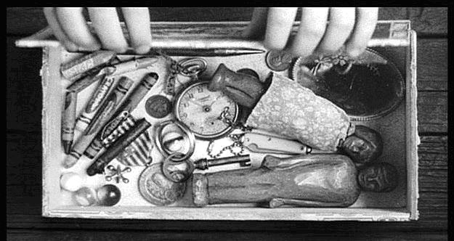
New Blog Post
□ Point Proof Explanation Paragraph
□ Open Ended Question

Blog Post Reply/Comment
□ Point Proof Explanation support OR rebuttal

- This is formative writing practice in preparation for your formal essay and for a blogging assignment attached to the novel study
- Blogs can be found on the course website: kbrucemiller.weebly.com
Su﻿ccess Criteria for Posts
- I have written in 3rd person, formal language
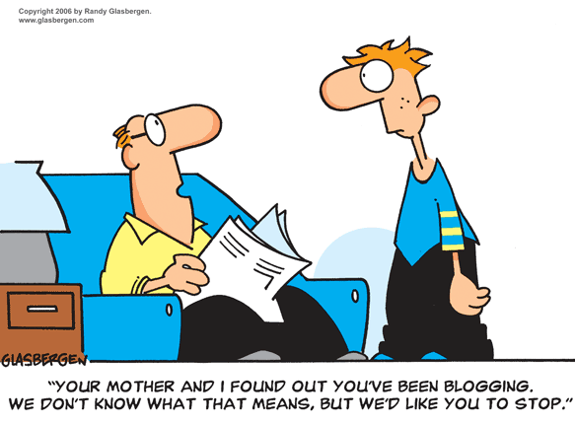
- My post is about 250 words in length
- My post shows I have thought about the content of the Act
- My post is detailed and specific
- I have supported my opinions with evidence from the text
- I have used direct quotations and examples as support
- I have properly cited direct quotations
- I have used proper paragraph and sentence structure
- I have checked my spelling
* My question will elicit in-depth conversations and is open ended
* I have answered all parts of the questions clearly
- Blogging Dates and Groups:
  - Tuesday May 27th – Group 1 Blogs (Chapters 1-5)
    - Dea, Alasdair, Faith, Sam, Mathieu
  - Monday June 2nd – Group 2 Blogs (Chapters 6-11)
    - Jessica, Eric, Sarah, Tamara, Justin
  - Thursday June 5th – Group 3 Blogs (Chapters 12-17)
    - Shelby, Simon, Riley, Sloane, Ahmad
  - Monday June 9th – Group 4 Blogs (Chapters 18-23)
    - Ciara, Quay, Angel, Michaela, Steven
  - Friday June 13th – Group 5 Blogs (Chapters 24-31)
    - Zane, Shawnee, Numa, Alexa, Keira
*Reading for your blog section should be completed prior to the blogging date. Blogs will be completed as a “test”, where all must be posted by the end of class the day of (computer labs are booked for those days)
*When you have completed your blogging for the day, hand me the appropriate rubric, then you may read the novel or work on your summative visual essay.
RUBRIC for New Blog Post Name: ___________________________

 |  | 4 | 3 | 2 | 1 | R
KNOWLEDGE | Proof  RLS 1.3 | The proof is very well chosen, and provides excellent support to the point | The proof is well chosen, and provides good support to the point | The proof is adequately chosen, and provides some support to the point | The proof is not well chosen and provides little support to the point | No proof is provided, or proof lacks relevance to point
THINKING | Explanation  RLS 1.4 | Explanation is thorough and advanced | Explanation is somewhat thorough and advanced | Explanation is adequate but somewhat simplistic | Explanation is limited and simplistic | Explanation is inadequate, overly brief and simplistic or no explanation is provided
 | New Idea  W 1.2 | The ideas presented are highly unique | The ideas presented are unique | The ideas presented are somewhat common | The ideas presented are common | No new ideas are presented; they are repeats of other existing blog postings
 | Open Ended Question  W 2.1 | The open ended question is highly provocative | The open ended question is provocative | The open ended question is adequate | The open ended question is not stimulating | The question is irrelevant, dull and/or not open ended
 | Point  RLS 1.6 | The point made is highly insightful and germane | The point made is insightful and germane | The point made is somewhat insightful and germane | The point made lacks insight and relevance | The point is irrelevant and unperceptive
COMMUNICATION | Language  3rd person  Academic  W 2.2 | Language is advanced | Language is academic | Language is adequately academic | Language is limited academically | Language is not academic
 | Form  W 2.1 | Paragraph Structure is advanced | Paragraph structure is good | Paragraph structure is adequate | Paragraph structure is limited | Paragraphs are not used

RUBRIC for Response/Reply Posts (1/4) Name: ___________________________

 |  | 4 | 3 | 2 | 1 | R
KNOWLEDGE | Proof  RLS 1.3 | The proof is very well chosen, and provides excellent support to the point | The proof is well chosen, and provides good support to the point | The proof is adequately chosen, and provides some support to the point | The proof is not well chosen and provides little support to the point | No proof is provided, or proof lacks relevance to point
THINKING | Explanation  RLS 1.4 | Explanation is thorough and advanced | Explanation is somewhat thorough and advanced | Explanation is adequate but somewhat simplistic | Explanation is limited and simplistic | Explanation is inadequate, overly brief and simplistic or no explanation is provided
 | New Idea  W 1.2 | The ideas presented are highly unique | The ideas presented are unique | The ideas presented are somewhat common | The ideas presented are common | No new ideas are presented; they are repeats of other existing blog postings
 | Point  RLS 1.6 | The point made is highly insightful and germane | The point made is insightful and germane | The point made is somewhat insightful and germane | The point made lacks insight and relevance | The point is irrelevant and unperceptive
COMMUNICATION | Language  3rd person  Academic  W 2.2 | Language is advanced | Language is academic | Language is adequately academic | Language is limited academically | Language is not academic
 | Form  W 2.1 | Paragraph Structure is advanced | Paragraph structure is good | Paragraph structure is adequate | Paragraph structure is limited | Paragraphs are not used

RUBRIC for Response/Reply Posts (2/4) Name: ___________________________

 |  | 4 | 3 | 2 | 1 | R
KNOWLEDGE | Proof  RLS 1.3 | The proof is very well chosen, and provides excellent support to the point | The proof is well chosen, and provides good support to the point | The proof is adequately chosen, and provides some support to the point | The proof is not well chosen and provides little support to the point | No proof is provided, or proof lacks relevance to point
THINKING | Explanation  RLS 1.4 | Explanation is thorough and advanced | Explanation is somewhat thorough and advanced | Explanation is adequate but somewhat simplistic | Explanation is limited and simplistic | Explanation is inadequate, overly brief and simplistic or no explanation is provided
 | New Idea  W 1.2 | The ideas presented are highly unique | The ideas presented are unique | The ideas presented are somewhat common | The ideas presented are common | No new ideas are presented; they are repeats of other existing blog postings
 | Point  RLS 1.6 | The point made is highly insightful and germane | The point made is insightful and germane | The point made is somewhat insightful and germane | The point made lacks insight and relevance | The point is irrelevant and unperceptive
COMMUNICATION | Language  3rd person  Academic  W 2.2 | Language is advanced | Language is academic | Language is adequately academic | Language is limited academically | Language is not academic
 | Form  W 2.1 | Paragraph Structure is advanced | Paragraph structure is good | Paragraph structure is adequate | Paragraph structure is limited | Paragraphs are not used

RUBRIC for Response/Reply Posts (3/4) Name: ___________________________

 |  | 4 | 3 | 2 | 1 | R
KNOWLEDGE | Proof  RLS 1.3 | The proof is very well chosen, and provides excellent support to the point | The proof is well chosen, and provides good support to the point | The proof is adequately chosen, and provides some support to the point | The proof is not well chosen and provides little support to the point | No proof is provided, or proof lacks relevance to point
THINKING | Explanation  RLS 1.4 | Explanation is thorough and advanced | Explanation is somewhat thorough and advanced | Explanation is adequate but somewhat simplistic | Explanation is limited and simplistic | Explanation is inadequate, overly brief and simplistic or no explanation is provided
 | New Idea  W 1.2 | The ideas presented are highly unique | The ideas presented are unique | The ideas presented are somewhat common | The ideas presented are common | No new ideas are presented; they are repeats of other existing blog postings
 | Point  RLS 1.6 | The point made is highly insightful and germane | The point made is insightful and germane | The point made is somewhat insightful and germane | The point made lacks insight and relevance | The point is irrelevant and unperceptive
COMMUNICATION | Language  3rd person  Academic  W 2.2 | Language is advanced | Language is academic | Language is adequately academic | Language is limited academically | Language is not academic
 | Form  W 2.1 | Paragraph Structure is advanced | Paragraph structure is good | Paragraph structure is adequate | Paragraph structure is limited | Paragraphs are not used

RUBRIC for Response/Reply Posts (4/4) Name: ___________________________

 |  | 4 | 3 | 2 | 1 | R
KNOWLEDGE | Proof  RLS 1.3 | The proof is very well chosen, and provides excellent support to the point | The proof is well chosen, and provides good support to the point | The proof is adequately chosen, and provides some support to the point | The proof is not well chosen and provides little support to the point | No proof is provided, or proof lacks relevance to point
THINKING | Explanation  RLS 1.4 | Explanation is thorough and advanced | Explanation is somewhat thorough and advanced | Explanation is adequate but somewhat simplistic | Explanation is limited and simplistic | Explanation is inadequate, overly brief and simplistic or no explanation is provided
 | New Idea  W 1.2 | The ideas presented are highly unique | The ideas presented are unique | The ideas presented are somewhat common | The ideas presented are common | No new ideas are presented; they are repeats of other existing blog postings
 | Point  RLS 1.6 | The point made is highly insightful and germane | The point made is insightful and germane | The point made is somewhat insightful and germane | The point made lacks insight and relevance | The point is irrelevant and unperceptive
COMMUNICATION | Language  3rd person  Academic  W 2.2 | Language is advanced | Language is academic | Language is adequately academic | Language is limited academically | Language is not academic
 | Form  W 2.1 | Paragraph Structure is advanced | Paragraph structure is good | Paragraph structure is adequate | Paragraph structure is limited | Paragraphs are not used

