Synectics Home Drawings
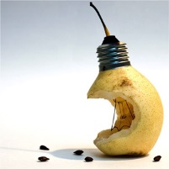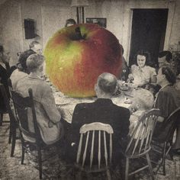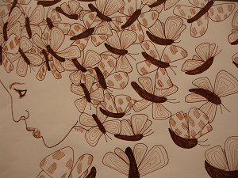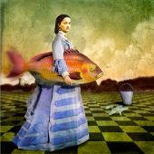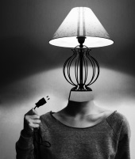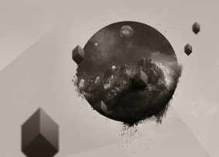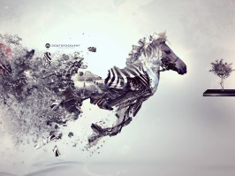
In your sketchbook, draw one mutation for each of the synectic categories:

Subtract
Add
Transfer
Empathize
Animate
Superimpose
Change scale
Substitute
Fragmentate
Isolate
Distort
Disguise
Contradict
Parody
Prevaricate
Analogize
Hybridize
Metamorphose
Symbolize
Mythologize
Fantasize
Repeat combine

Refer to the definition sheet provided, as well as the powerpoint found on the website, for examples.

You may adapt the same base image (ie a fork) for each of the drawings, but you will receive marks for creativity if a different image is used throughout.

RUBRIC Synectic Home Drawings Student Name:

Criteria:
Level R = none-insufficient Level 1 = limited Level 2 = somewhat Level 3 = considerably Level 4 = thoroughly
(50 - 59%) (60 - 69%) (70 - 79%) (80 - 100%)

Knowledge and Understanding (Understanding of concepts, elements, principles, meaning and significance)
• Demonstrates an understanding of each synectic category | R 1 2 3 4 | overall mark for category:  /10

Thinking and Inquiry (Planning & Process; Creative thinking skills & processes, critical analysis)
• A variety of objects (subjects) are being mutated  • Mutations are creative and original | R 1 2 3 4  R 1 2 3 4 | overall mark for category:  /20

Communication (The conveying of meaning through various forms; communication of intended message expression/organization of ideas)
The completed rubric answers:  • The rubric questions have been thoroughly answered and were properly submitted with your completed assignment and demonstrate attention to details and thoughtful, insightful answers.  • Synectic term is well communicated through the drawing | R 1 2 3 4  R 1 2 3 4 | overall mark for category:  /20

Application (The use and knowledge to make connections within and between various contexts; final product, composition, creativity)
Foundations: Responsible Practices.  • Throughout the creation of this piece you demonstrated responsible studio practice by: Maintaining a clean, respectful workspace; Consistent, proper, safe materials usage; Not wasting/losing materials/tools/equipment; Responsible, ethical digital citizenship.  Application:  • Professional presentation of the final product (clean, unwrinkled papers) | R 1 2 3 4  R 1 2 3 4 | overall mark for category:  /20
RUBRIC QUESTION: * Answer this questions on a different piece of paper to allow yourself space to fully discuss. Provide a full paragraph for your answer (a minimum of 5 sentences).
- Which synectic drawing is your favourite and why?

