Sketchbook Assignment Facebook Critique #1

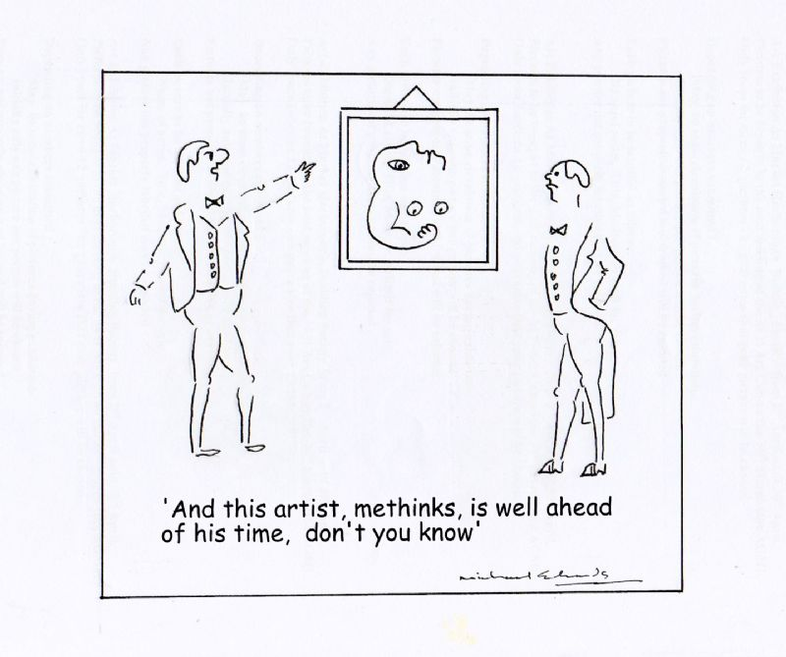
You must comment a total of 5 times, on 5 different photos, from at least 3 different categories in the facebook group

Please follow the following format:
Describe, Analyse, Interpret, Decide.
Please include a minimum of one sentence per element.

- Selfie comments were practice and
will not be considered for this assignment.

AWQ 3O - Rubric
Student Name:
Criteria:
Level R = none-insufficient Level 1 = limited Level 2 = somewhat Level 3 = considerably Level 4 = thoroughly
(50 - 59%) (60 - 69%) (70 - 79%) (80 - 100%)

Knowledge and Understanding (Understanding of concepts, elements, principles, meaning and significance)
• Demonstrates an understanding of all the elements of critique (Describe, Analyse, Interpret, Decide) | R 1 2 3 4 | overall mark for category:  /10

Thinking and Inquiry (Planning & Process; Creative thinking skills & processes, critical analysis)
Critical Analysis  • Description is correct, thorough, unique and insightful  • Analysis is thorough, unique and insightful  • Interpretation is thorough, unique and insightful  • Judgement/Decisions are thorough, unique and insightful  - At least one sentence per portion  All critiques were completed and posted on time | R 1 2 3 4  R 1 2 3 4  R 1 2 3 4  R 1 2 3 4  R 1 2 3 4 | overall mark for category:  /50

Communication (The conveying of meaning through various forms; communication of intended message expression/organization of ideas)
Critique is well organized and clearly communicated | R 1 2 3 4 | overall mark for category:  /10

Application (The use and knowledge to make connections within and between various contexts; final product, composition, creativity)
Foundations: Responsible Practices.  • Responsible, ethical digital citizenship. | R 1 2 3 4 | overall mark for category:  /10

Sketchbook Assignment Facebook Critique #2

You must comment a total of 5 times, on 5 different photos, from at least 3 different categories in the facebook group

Please follow the following format:
Describe, Analyse, Interpret, Decide.
Please include a minimum of one sentence per element.

- Selfie comments were practice and
will not be considered for this assignment.

AWQ 3O - Rubric
Student Name:
Criteria:
Level R = none-insufficient Level 1 = limited Level 2 = somewhat Level 3 = considerably Level 4 = thoroughly
(50 - 59%) (60 - 69%) (70 - 79%) (80 - 100%)

Knowledge and Understanding (Understanding of concepts, elements, principles, meaning and significance)
• Demonstrates an understanding of all the elements of critique (Describe, Analyse, Interpret, Decide) | R 1 2 3 4 | overall mark for category:  /10

Thinking and Inquiry (Planning & Process; Creative thinking skills & processes, critical analysis)
Critical Analysis  • Description is correct, thorough, unique and insightful  • Analysis is thorough, unique and insightful  • Interpretation is thorough, unique and insightful  • Judgement/Decisions are thorough, unique and insightful  - At least one sentence per portion  All critiques were completed and posted on time | R 1 2 3 4  R 1 2 3 4  R 1 2 3 4  R 1 2 3 4  R 1 2 3 4 | overall mark for category:  /50

Communication (The conveying of meaning through various forms; communication of intended message expression/organization of ideas)
Critique is well organized and clearly communicated | R 1 2 3 4 | overall mark for category:  /10

Application (The use and knowledge to make connections within and between various contexts; final product, composition, creativity)
Foundations: Responsible Practices.  • Responsible, ethical digital citizenship. | R 1 2 3 4 | overall mark for category:  /10

