Single Point Perspective

- Linear Perspective is a _______________ used to represent __________-dimensional images on a ___________-dimensional picture plane.
- Linear Perspective helps artists to create the illusion of __________ and ______________.

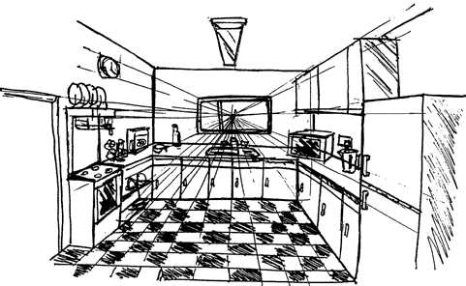

- The horizon line in _____________ drawing is a horizontal line _________ the picture. It is always at ___________ level - its __________ determines where we seem to be looking __________ - a high place, or from close to the ground. The actual horizon might not be ___________, but you need to draw a '___________' horizon to construct a picture in __________________.
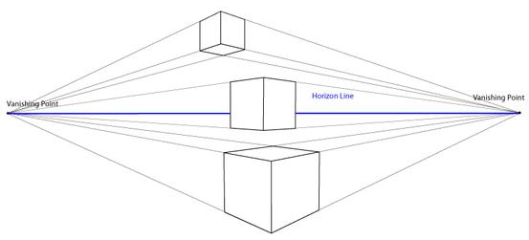
This is two point persective - - -
- In Linear Perspective drawing, Vanishing Point, is the point(s) on the ____________ to which the receding ______________ lines _______________.

