Set Planning Sheet

Setting Location Description
Set Pieces | Stage Location (use proper terminology)
Props | Stage Location (use proper terminology)
Backdrop description
Colour Scheme | Intended Mood (colour symbolism)
Balance on Stage | Focus/Dominance on Stage
Rough Set Drawing
FRONTAL VIEW
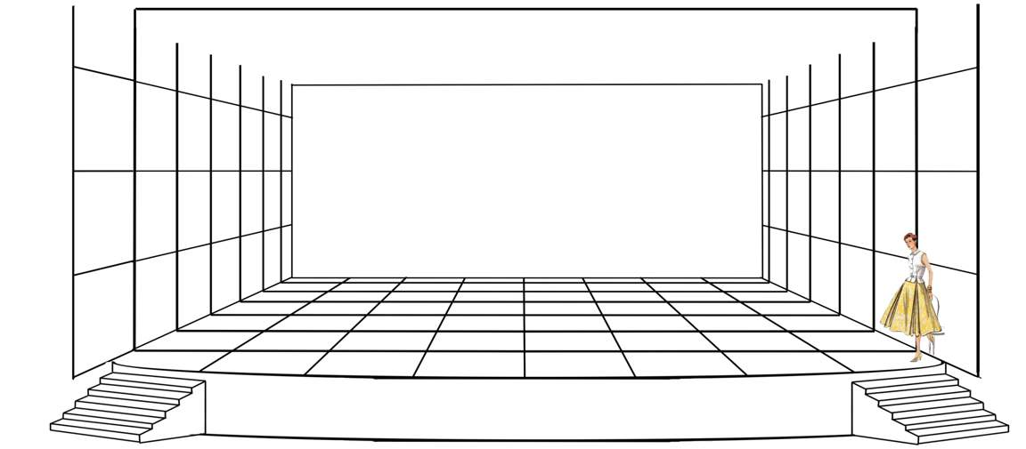

* ignore the woman ;)

ARIAL VIEW (overhead)

