Self-Portrait Assignment

The Creative Process:
Apply understanding of value scales to create art works for the purpose of self-expression and to communicate ideas, information, and/or messages;
Produce a self-portrait, using graphite on paper

The Critical Analysis:
Demonstrate an understanding of the critical analysis process by evaluating, and reflecting on your success

Foundations:
Demonstrate an understanding of drawing techniques (gridding, facial proportions) used in the creation of visual art works;
Responsible Practices: demonstrate an understanding of responsible practices related to visual arts.

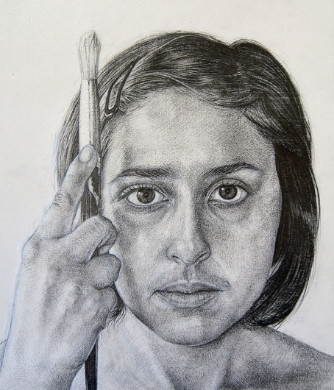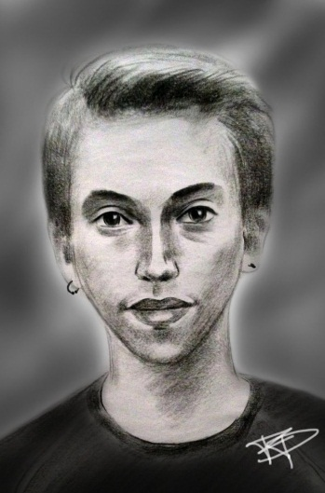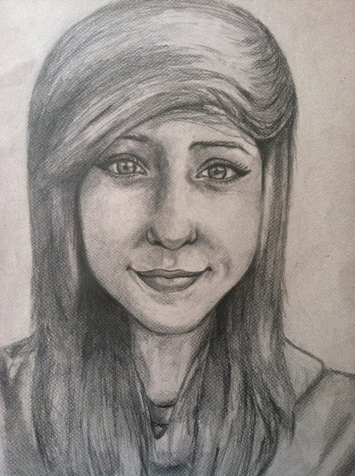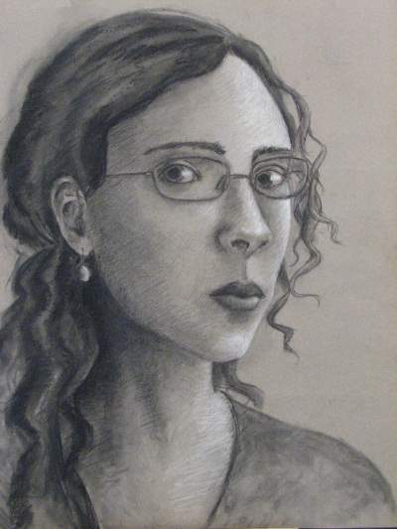

Each student will draw a self-portrait of themselves on 11.5x17.5 white paper with graphite.

- Have a photo taken of yourself by the teacher
- Faintly rid your large paper with 5x7 squares (measure carefully with a ruler)
- Lightly sketch out the outline and placement of your features, using the acetate grid as reference, over your original photo.
- Erase your grid lines
- Go back in and shade, creating realism within the image, referencing your practice sheets. Focus on each individual feature one by one.
* use continuous shading, stippling and hatching where appropriate.
* use a variety of pencils to create lightest lights, mid tones and darkest darks.
* go back in with your eraser to create highlights
* pay attention to the direction of light
- Clean up your paper. Retouch any areas that need it, then have the teacher apply spray adhesive to fix your final image

RUBRIC Self Portrait Student Name:

Criteria:
Level R = none-insufficient Level 1 = limited Level 2 = somewhat Level 3 = considerably Level 4 = thoroughly
(50 - 59%) (60 - 69%) (70 - 79%) (80 - 100%)

Knowledge and Understanding (Understanding of concepts, elements, principles, meaning and significance)
• Demonstrates an understanding of gridding  • Demonstrates an understanding of facial proportions  • Demonstrates an understanding of drawing techniques (shading, stippling, hatching)  • Demonstrates an understanding of no contour drawing (no outlines) | R 1 2 3 4  R 1 2 3 4  R 1 2 3 4  R 1 2 3 4 | overall mark for category:  /40

Thinking and Inquiry (Planning & Process; Creative thinking skills & processes, critical analysis)
Planning & Process  • facial proportions, facial elements and gridding sheets completed  (in sketchbook and notebook) | R 1 2 3 4 | overall mark for category:  /10

Communication (The conveying of meaning through various forms; communication of intended message expression/organization of ideas)
The completed rubric answers:  • The rubric questions have been thoroughly answered and were properly submitted with your completed assignment.  • The rubric answers demonstrate attention to details and thoughtful, insightful answers. | R 1 2 3 4  R 1 2 3 4 | overall mark for category:  /20

Application (The use and knowledge to make connections within and between various contexts; final product, composition, creativity)
Foundations: Responsible Practices.  • Throughout the creation of this piece you demonstrated responsible studio practice by: Maintaining a clean, respectful workspace; Consistent, proper, safe materials usage; Not wasting/losing materials/tools/equipment; Responsible, ethical digital citizenship.  Application:  • Professional presentation of the final product (clean, unwrinkled paper)  • Gridding technique used is accurate  • Full spectrum of value scales are created through drawing techniques  (lightest lights and darkest darks)  • Smooth transitions are used in the continuous value scale  • Graphite use/technique is appropriate for each drawing style (line type, pencil type, etc.)  • Contours of object are effectively created, without the use of contour lines  • Light source is accurate, consistent and well depicted  • A true likeness is created to the subject  • Facial proportions are accurate  • Facial features are detailed and realistic | R 1 2 3 4  R 1 2 3 4  R 1 2 3 4  R 1 2 3 4  R 1 2 3 4  R 1 2 3 4  R 1 2 3 4  R 1 2 3 4  R 1 2 3 4  R 1 2 3 4  R 1 2 3 4 | overall mark for category:  /110
RUBRIC QUESTIONS: * Answer these questions on a different piece of paper to allow yourself space to fully discuss. Provide a full paragraph for each answer (a minimum of 5 sentences).
- What did you find challenging about this assignment and how did you overcome it?
- Do you believe you created a true likeness of yourself in this piece? Define this by discussing certain parts of the drawing. What could you have done differently to improve it?
- Did you find the gridding or the facial proportions more helpful to your success? Why?

