Science Fiction or Fantasy?
You work in entertainment marketing and were assigned to categorize the following films as either science fiction or fantasy based on their plot summaries. Consider the definition we discussed in class, and determine what genre each film is. Then briefly explain your decision.

1) Hollow Man (2000) | Plot Summary:  Sebastian Caine and his team have worked tirelessly to develop a formula that can not only turn animals invisible but also bring them back to normal at will. With Governmental pressure on them to show results, Sebastian decides he will be the first human to try the formula. He becomes invisible for a short time, however efforts to bring him back fail and he finds himself stuck. As work continues on the formula, the others in the lab begin to notice him becoming increasingly unhinged.  Written by <m_sanchero@hotmail.com> http://www.imdb.com/title/tt0164052/
Sci-fi or Fantasy? | Explanation:
2) Teenage Mutant Ninja Turtles (1990) | Plot Summary:  Through contact with a mysterious substance, called Ooze, 4 little turtles in the canalization of New York mutate to giant turtles. They can speak, walk upright and love pizza. The wise rat Splinter becomes their mentor and educates them to Ninja fighters. Their arch-enemy is the bad, bad guy Shredder, who struggles to gain power over the world. Of course the ninja turtles will do everything to stop him.  Written by Tom Zoerner <http://www.imdb.com/title/tt0100758/>
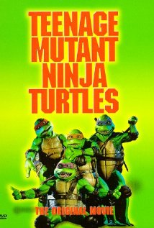
Sci-fi or Fantasy? | Explanation:
3) The Wizard of Oz (1939) | Plot Summary:  When a nasty neighbor tries to have her dog put to sleep, Dorothy takes her dog Toto, to run away. A cyclone appears and carries her to the magical land of Oz. Wishing to return, she begins to travel to the Emerald City where a great wizard lives. On her way she meets a Scarecrow who needs a brain, a Tin Man who wants a heart, and a Cowardly Lion who desperately needs courage. They all hope the Wizard of Oz will help them, before the Wicked Witch of the West catches up with them.  Written by  http://www.imdb.com/search/title?plot_author=The%20Massie%20Twins&view=simple&sort=alpha
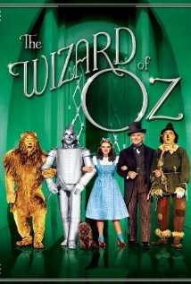
Sci-fi or Fantasy? | Explanation:
4) The Day After Tomorrow (2004) | Plot Summary:  As Paleoclimatologist named Jack Hall is in Antartica, he discovers that a huge ice sheet has sheared off. But what he does not know is that this event will trigger a massive climate shift that will affect the world population. Meanwhile, his son Sam is with friends in New York to attend an event. There they discover that it has been raining non-stop for the past 3 weeks, and after a series of weather-related disasters begin to occur over the world, everybody realizes the world is entering a new Ice Age and the world population begins trying to evacuate to the warmer climates of the south. Jack makes a daring attempt to rescue his son and his friends who are stuck in New York and who have managed to survive not only a massive wave but also freezing cold temperatures that could possibly kill them.  Written by Warner Bros. Pictureshttp://www.imdb.com/title/tt1375666/
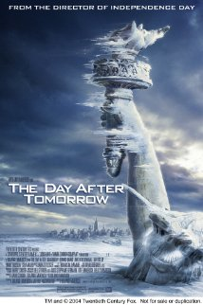
Sci-fi or Fantasy? | Explanation:
5) Transformers (2007) | Plot Summary:  A long time ago, far away on the planet of Cybertron, a war is being waged between the noble Autobots (led by the wise Optimus Prime) and the devious Decepticons (commanded by the dreaded Megatron) for control over the Allspark, a mystical talisman that would grant unlimited power to whoever possesses it. The Autobots managed to smuggle the Allspark off the planet, but Megatron blasts off in search of it. He eventually tracks it to the planet of Earth (circa 1850), but his reckless desire for power sends him right into the Arctic Ocean, and the sheer cold forces him into a paralyzed state. His body is later found by Captain Archibald Witwicky, but before going into a comatose state Megatron uses the last of his energy to engrave into the Captain's glasses a map showing the location of the Allspark, and to send a transmission to Cybertron. Megatron is then carried away aboard the Captain's ship. A century later, Captain Witwicky's grandson Sam Witwicky (nicknamed Spike by his friends) buys his first car. To his shock, he discovers it to be Bumblebee, an Autobot in disguise who is to protect Spike, who possesses the Captain's glasses and the map engraved on them. But Bumblebee is not the only Transformer to have arrived on Earth - in the desert of Qatar, the Decepticons Blackout and Scorponok attack a U.S. military base, causing the Pentagon to send their special Sector Seven agents to capture all "specimens of this alien race." Spike and his girlfriend Mikaela find themselves in the midst of a grand battle between the Autobots and the Decepticons, stretching from Hoover Dam all the way to Los Angeles. Meanwhile, deep inside Hoover Dam, the cryogenically stored body of Megatron awakens.  Written by Warner Bros. Pictureshttp://www.imdb.com/title/tt1375666/
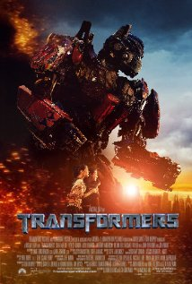
Sci-fi or fantasy? | Explanation:
How many films did you identify correctly as science fiction?

Can you think of any other science fiction films or TV shows?

