Rules of Composition Project
Curriculum Expectations
A1. The Creative Process: apply the creative process to create unique photos
A2. The Elements and Principles of Design: apply understanding of texture and pattern to create art works for the purpose of self-expression and to communicate ideas, information, and/or messages;
A3. Production and Presentation: produce art works, using film photography and darkroom development
B1. The Critical Analysis Process: demonstrate an understanding of the critical analysis process by examining, interpreting, evaluating, your own artwork
C1. Terminology: demonstrate an understanding of, and use correct terminology when referring to, elements, principles, and rules of composition
C2. Conventions and Techniques: demonstrate an understanding of rules of composition, film camera usage and paper development in the creation of your photos
C3. Responsible Practices: demonstrate an understanding of responsible practices related to visual arts.

For this assignment you will take photos focusing on textures and patterns, using the rules of composition as your guidelines:

- Fill the frame
- Rule of odds
- Rule of thirds
- Leading lines
- Vary your sizes and lines
- Mergers
- Aspect ratio

Each photo should be using at least 4 of the rules of composition.
You will take 4 photos of different subjects creating interesting and effective compositions.
Step One: scope the school and plan your 4 photos in your sketchbook
Step Two: conference with your teacher
Step Three: Capture your photos on the point n shoot camera (use the film tracking sheet with your group to keep your photos in order

Step Four: Develop your film (with film your group)

Step Five: Develop your photos (test strip then full photo with optimal exposure and development time)

Step Six: Choose your best photo and mat and mount it
* submit ALL photo attempts and test strips

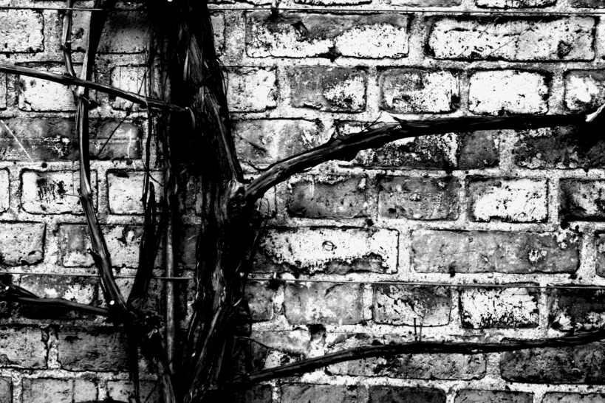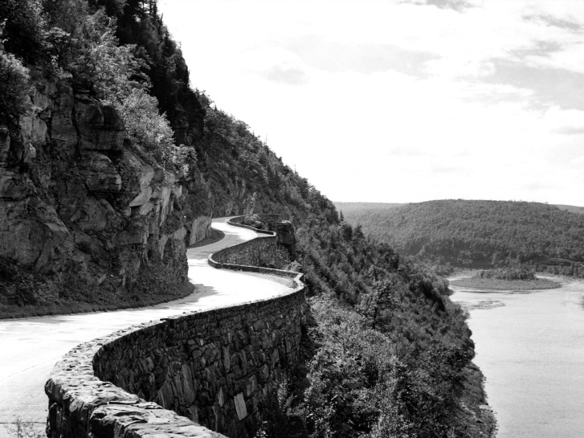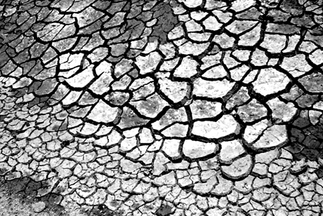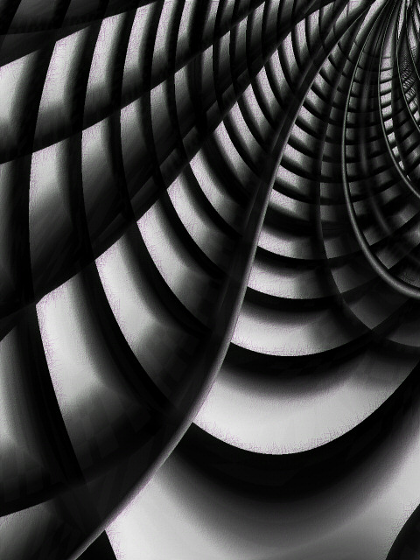
*ideas: lockers, library books, artworks textbooks, floor or ceiling tiles, urinals, bulletin boards, art supplies, cafeteria tables, classroom desks, etc.

RUBRIC
Student Name:
Criteria:
Level R = none-insufficient Level 1 = limited Level 2 = somewhat Level 3 = considerably Level 4 = thoroughly
(50 - 59%) (60 - 69%) (70 - 79%) (80 - 100%)

Knowledge and Understanding (Understanding of concepts, elements, principles, meaning and significance)
• Demonstrates an understanding of Rules of Composition  • Demonstrates an understanding of Texture and Pattern  • Demonstrates an understanding of Film Development  • Demonstrates an understanding of Paper Exposure  • Demonstrates an understanding of Paper Development | R 1 2 3 4  R 1 2 3 4  R 1 2 3 4  R 1 2 3 4  R 1 2 3 4 | overall mark for category:  /50

Thinking and Inquiry (Planning & Process; Creative thinking skills & processes, critical analysis)
Planning & Process  • evidence of thorough proposal/rough drafts/ preliminary planning, documented (in sketchbook)  *4 sketchbook sketches with camera settings  • effective teacher-conferencing in a timely manner  • your work was prepared on time for class critiques, peer feedback  • student has successfully used test strips | R 1 2 3 4  R 1 2 3 4  R 1 2 3 4  R 1 2 3 4  R 1 2 3 4 | overall mark for category:  /50

Communication (The conveying of meaning through various forms; communication of intended message expression/organization of ideas)
The completed rubric answers:  • The rubric questions have been thoroughly answered and were properly submitted with your completed assignment and demonstrate attention to details and thoughtful, insightful answers. | R 1 2 3 4 | overall mark for category:  /10

Application (The use and knowledge to make connections within and between various contexts; final product, composition, creativity)
Foundations: Responsible Practices.  • throughout the creation of this piece you demonstrated responsible studio practice by: Maintaining a clean, respectful workspace; Consistent, proper, safe materials usage; Not wasting/losing materials/tools/equipment; Responsible, ethical digital citizenship.  Application:  • Final Arrangement’s compositions are creative and unique  • Final Compositions demonstrate an advanced understanding of Rules of Composition  • Chosen Textures are Interesting and Effective  • Final Images demonstrate an advanced understanding of film development  • Final Images demonstrate an advanced understanding of film enlarging  • Final Images demonstrate an advanced understanding of paper development  • Final print is clean, professional (free of wrinkles, fingerprints, etc.)  • Matting is professional and accurate (all portions included) | R 1 2 3 4  R 1 2 3 4  R 1 2 3 4  R 1 2 3 4  R 1 2 3 4  R 1 2 3 4  R 1 2 3 4  R 1 2 3 4  R 1 2 3 4  R 1 2 3 4 | overall mark for category:  /100

Rubric Questions:
*To be typed on a separate sheet. Each question should be a full paragraph (minimum 5 sentences each)
- Along with your best photo, submit a through description of how you utilized the Rules of Composition
- Describe your role in the film development process
- Describe any issues you faced with photo capturing, photo enlarging and photo developing and how you tackled them

