RULES OF COMPOSITION - NOTE
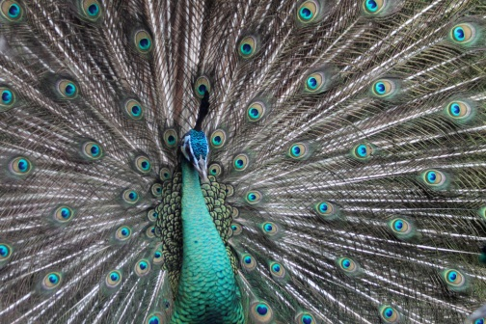
- Fill The _____________________
Gives your object _________________________.
Decide how ___________ your subject is and then give him/her a ratio of the frame that is directly related to his/her importance.

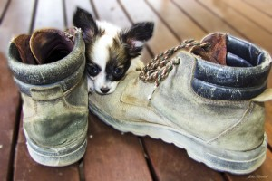
- Rule of _______________
The eye tends to be more _____________ with images that contain an ________ number of elements rather than an __________ number.
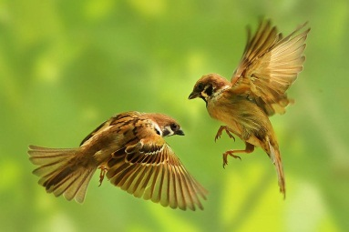
The human eye will naturally wander towards the ___________ of a group. If there’s _________ space there, then that’s where the eye will fall. You want your viewer to look at a __________, not at an empty space.
Breaking this rule can create tension, interesting and story

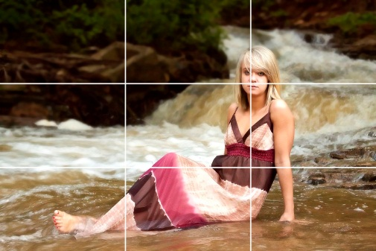
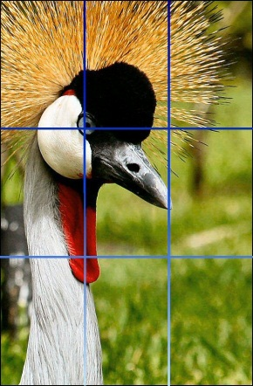
- Rule of ___________
use your eye to roughly divide your image with _________ lines into ________ equal-sized parts, then place your subject at the _________ of those lines.
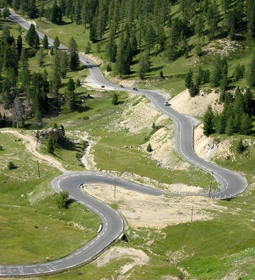
- _____________ Lines
When we look at a photo our eye is naturally drawn along ____________.
By thinking about how you __________ lines in your composition, you can affect the way we view the image, ________________ us into the picture, ______________ the subject, or on a journey "_____________" the scene.
There are many different __________ of line - straight, diagonal, curvy, zigzag, radial etc - and each can be used to ______________ our photo's composition.
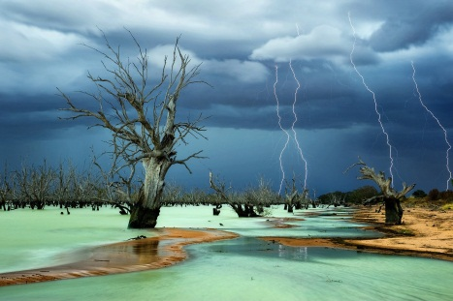
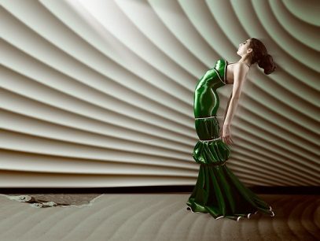
- __________ your lines
Horizontal lines lend a _______, __________ feel to a picture, while vertical ones often suggest ___________ and _____________. To introduce a feeling of drama, movement or uncertainty, look for ________________ lines instead.
- ______________ your size
Varying the size of objects adds interest and strategic focus
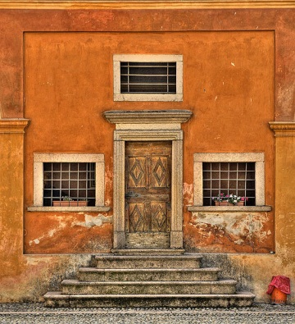
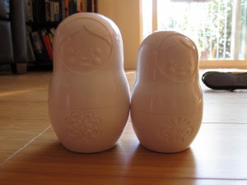
- ______________ the pattern
break the ___________ or pattern in some way, introducing __________ and a ___________ point to the scene.
- Object to ___________ Mergers
space objects ______________ OR _________________ them
never have objects awkwardly ____________ edge to edge
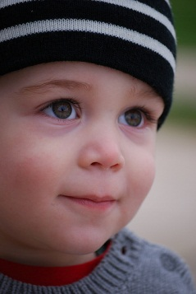
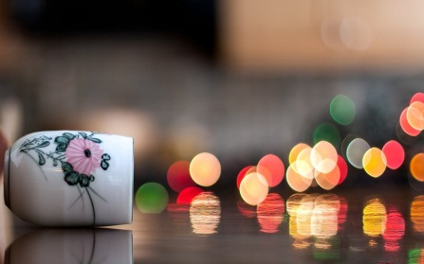
- Object to ______________ Mergers
Never have an object ____________ the frame. Either ______________ it (crop) or allow ________________ between it and the _______________
Crop to focus in on a subject, but leave space where required.
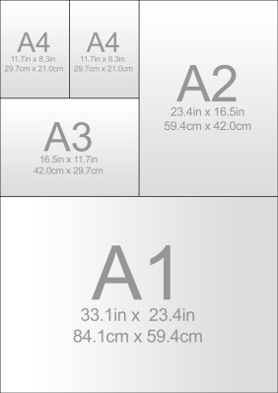
Here space is needed to imply where the subject is looking
- Aspect _______________
The aspect ratio of a ________________ shape is the ratio between its _______________ in different __________________. For example, the aspect ratio of a rectangle is the ratio of its longer side to its shorter side - the ratio of ______________ to _______________, when the rectangle is oriented as a "landscape".
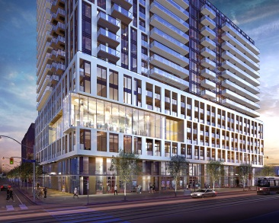
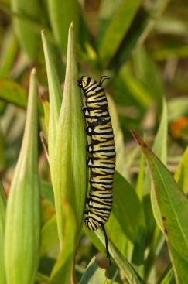
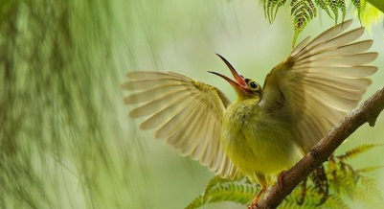
So, _________________ the aspect ratio of you photos – don’t always take them the same way (horizontal vs vertical)
- Simplification
look for ___________________ background elements and ______________ them out whenever you can.
Ask yourself: does this element __________________ to my composition?
