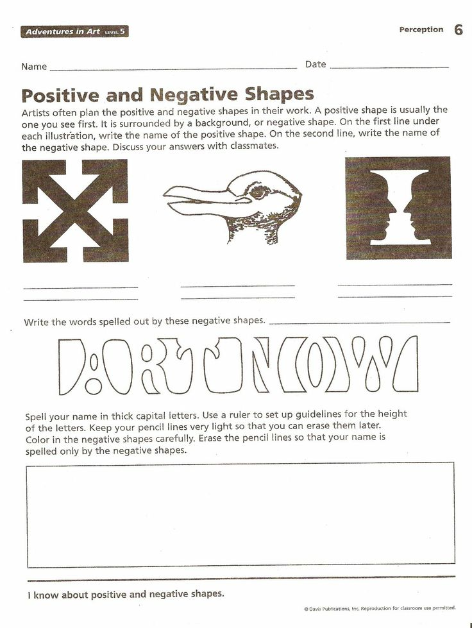
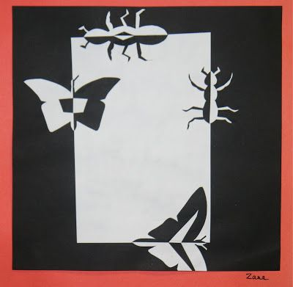

Using construction paper, create your own positive negative image like the one above. Paste it in your sketchbook or in the space provided below:

