PINHOLE CAMERA ASSIGNMENT
CURRICULUM EXPECTATIONS
A1. apply the creative process to create a successful pinhole camera and contact print
A3. produce pinhole camera photos and contact print, using a variety of materials tools, and techniques
B3. demonstrate an understanding of the types of knowledge and skills developed in the creation and use of a pinhole camera, developing photos and creating a contact print
C1. demonstrate an understanding of, and use correct terminology when referring to your pinhole camera, photo development and contact print
C2. demonstrate an understanding of conventions and techniques used in the creation of your pinhole camera, developed photos and contact print
C3. demonstrate an understanding of responsible practices related to building your pinhole camera, taking your photos and developing your prints

You will submit:
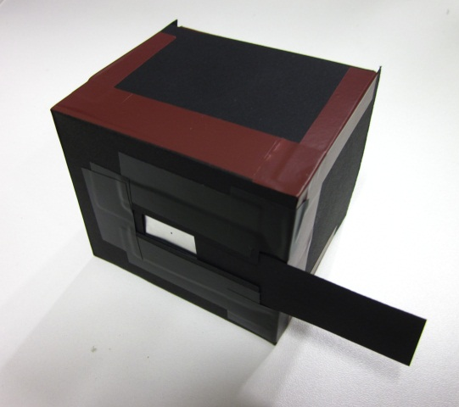
1- your preliminary research and plans
(in sketchbook) – Steps 2 & 6
2 - a camera created by you
3- two negative images, you have developed, made
with the camera
(one outdoor, one indoor)
4- one positive contact of your best image
5- your rubric along with your rubric questions

What you need for this assignment:
1. A light-tight enclosure with an aperture to admit light and a shutter to expose your paper
2. photo-sensitive material – use the photo paper you have been supplied
3. light. Image can be made in any light level, however:
- light of objects in bright sun are 16 times brighter than shaded
- indoor lighting is 10 times darker than outdoor shade
- therefore: images made outside are short, those inside are long
4. a dark room
5. paper developer, stop and fix
6. A photo enlarger (to produce the contact print)

Other Considerations:
- Your aperture can be any size, but remember:
  - The smaller the aperture, the sharper the image
  - The smaller the aperture, the longer the exposure needed.
- Make the pinhole aperture out of a “thin” material. If not, it will have a tunnel-light image
- Beware of “thin” materials like construction paper for the construction of your camera body as it must not permit any light into the vessel
- If the inside of your camera is reflective, you may get some bouncing/scattering of light that will degrade/darken the image. To correct, coat the inside of the camera with a matte material, such as flat-black paint or dark construction paper.
- The size of your camera back will be the size of you final photo
- You cannot hand-hold a camera “steady” for the times required in this
assignment. It must be made immovable, and the subject must remain still. If not, there will be a blurred image.
- Expose your paper: at least 15 for seconds, sunny outside
At least 2 minutes, bright inside
*adjust accordingly
  - If image is too light, re-expose to more light (try double or more!).
  - If image is too dark, it needs to be re-exposed to less light (half or less).

Step 1: Research Pinhole cameras (internet, class videos and handouts)
Step 2: Plan your camera in your sketchbook – drawings and detailed notes
Step 3: Conference with your teacher
Step 4: Build your camera
Step 5: Have your camera teacher-approved
Step 6: Plan your two photos in your sketchbook (using the template provided)
– one to be taken outside and one inside
Step 7: Capture your first photo, with your pinhole camera,
and develop the negative print in the darkroom
Step 8: Capture your second photo and develop the negative print in the darkroom
* retake your photos if necessary, adjusting the exposure times to get a good print
Step 9: Create a contact print of your best photo
Step 10: Mount your photos and submit all of your work for final grading
AWQ 3O - Pinhole Camera Rubric
Student Name:
Criteria:
Level R = none-insufficient Level 1 = limited Level 2 = somewhat Level 3 = considerably Level 4 = thoroughly
(50 - 59%) (60 - 69%) (70 - 79%) (80 - 100%)

Knowledge and Understanding (Understanding of concepts, elements, principles, meaning and significance)
• Demonstrates an understanding of pinhole camera fabrication  • Demonstrates an understanding of camera exposure  • Demonstrates an understanding of paper development  • Demonstrates an understanding of contact printing | R 1 2 3 4  R 1 2 3 4  R 1 2 3 4 | overall mark for category:  /30

Thinking and Inquiry (Planning & Process; Creative thinking skills & processes, critical analysis)
Planning & Process  • evidence of thorough brain–storming, preliminary planning, documented and submitted on time  (in sketchbook) *for creation of pinhole camera  • A thorough proposal/rough drafts/experiments were submitted on time, are recorded in your sketchbook, and demonstrate thorough exploration of your ideas.  * for 2 photos to be taken  • your pinhole camera photos were prepared on time for class critiques, peer feedback  • your contact print was prepared on time for class critiques, peer feedback  Problem Solving  • The problem of creating a successful pinhole camera  • Your creativity of creating a unique camera design  • The problem of capturing the photo you had originally planned was successful  (composition and exposure)  • The problem of developing the photo on your paper  • The problem of developing your contact prints | R 1 2 3 4  R 1 2 3 4  R 1 2 3 4  R 1 2 3 4  R 1 2 3 4  R 1 2 3 4  R 1 2 3 4  R 1 2 3 4 | overall mark for category:  /80

Communication (The conveying of meaning through various forms; communication of intended message expression/organization of ideas)
The completed rubric answers:  • The rubric questions have been thoroughly answered and were properly submitted with your completed assignment and demonstrate attention to details and thoughtful, insightful answers. | R 1 2 3 4 | overall mark for category:  /10

Application (The use and knowledge to make connections within and between various contexts; final product, composition, creativity)
Foundations: Responsible Practices.  • throughout the creation of this piece you demonstrated responsible studio practice by: Maintaining a clean, respectful workspace; Consistent, proper, safe materials usage; Not wasting/losing materials/tools/equipment; Responsible, ethical digital citizenship.  Application:  • Pinhole camera is well fabricated  • Photo captures are effective  • Photo development is balanced and effective  • Contact print is effectively produced  • Final display of photos is professional and well presented | R 1 2 3 4  R 1 2 3 4  R 1 2 3 4  R 1 2 3 4  R 1 2 3 4  R 1 2 3 4 | overall mark for category:  /60
Rubric Questions:
* should be answered on a separate sheet. A minimum of 5 sentences per question is expected.
- What were the challenges you faced during the fabrication of your pinhole camera? How did you resolve them?
- List the sources you used to inspire the style of your camera, and what information you decided to use in the creation and why?
- What challenges did you observe/face during the taking of your photo? How did you resolve them?
- What challenges did you observe/face during the development of your photo negative? How did you resolve them?
- What challenges did you observe/face during the development of your photo positive (contact print)? How did you resolve them?
- If repeating this project, what specific things would you do differently and why?

