Photoshop Digital Darkroom Assignment

Task One: Adjust Contrast

For this task you will explore 4 different ways to adjust and heighten the contrast on one of your original film photographs
Adjust your ORIGINAL photo 4 times:
- Auto tone/auto adjust
- Brightness and Contrast Levels
- Exposure Adjustment Layer
- Gradient Map
Submit each of these, as well as your original photo, as a separate jpg files to your online hand in folder

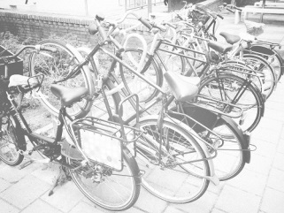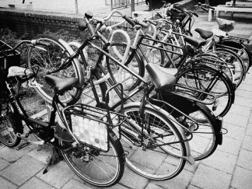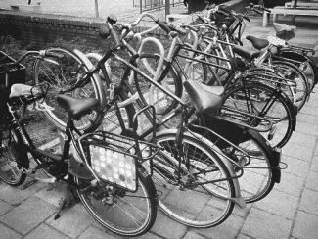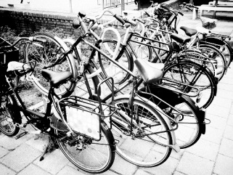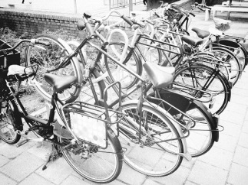

Task Two: Colorization

For this task you will realistically colourize one of your original film photographs.

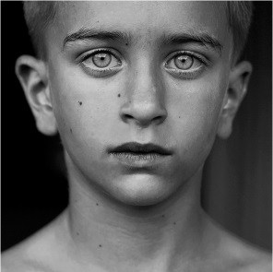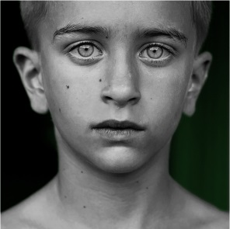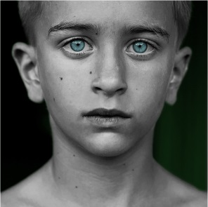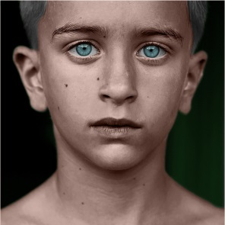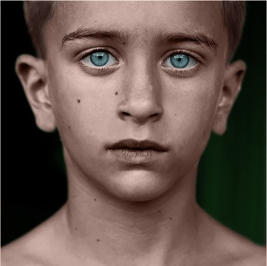

Task Three: Double Exposure

For this task you will create a digital double exposure, merging two of your photos. Watch the video to the point of altering the opacity of the top layer. If you are so inclined you can follow the rest through to do the second portion of the directions.

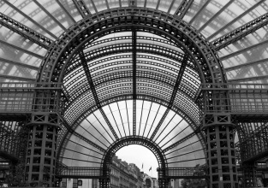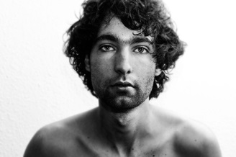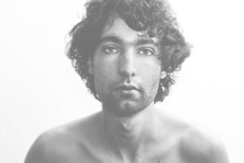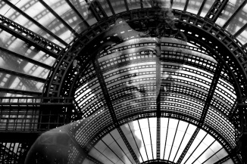

RUBRIC
Student Name:
Criteria:
Level R = none-insufficient Level 1 = limited Level 2 = somewhat Level 3 = considerably Level 4 = thoroughly
(50 - 59%) (60 - 69%) (70 - 79%) (80 - 100%)

Knowledge and Understanding (Understanding of concepts, elements, principles, meaning and significance)
• Demonstrates an understanding of auto tone and adjust  • Demonstrates an understanding of brightness contrast levels  • Demonstrates an understanding of exposure adjustment layers  • Demonstrates an understanding of gradient maps  • Demonstrates an understanding of colorization  • Demonstrates an understanding of double exposure | R 1 2 3 4  R 1 2 3 4  R 1 2 3 4 | overall mark for category:  /30

Thinking and Inquiry (Planning & Process; Creative thinking skills & processes, critical analysis)
Planning  • Photo for improved contrast task is well chosen  • Photo for colourization task is well chosen  • Photos for double exposure task are well chosen | R 1 2 3 4  R 1 2 3 4  R 1 2 3 4 | overall mark for category:  /30

Communication (The conveying of meaning through various forms; communication of intended message expression/organization of ideas)
The completed rubric answers:  • The rubric questions have been thoroughly answered and were properly submitted with your completed assignment.  • The rubric answers demonstrate attention to details and thoughtful, insightful answers.  • Colours for colourization are well chosen and suit the photo content and mood  • Double exposure image communicated an interesting message | R 1 2 3 4  R 1 2 3 4  R 1 2 3 4  R 1 2 3 4 | overall mark for category:  /40

Application (The use and knowledge to make connections within and between various contexts; final product, composition, creativity)
Foundations: Responsible Practices.  • throughout the creation of this piece you demonstrated responsible studio practice by: Maintaining a clean, respectful workspace; Consistent, proper, safe materials usage; Not wasting/losing materials/tools/equipment; Responsible, ethical digital citizenship.  Application:  • Final Arrangement of double exposure is effective  • Photoshop tools are used effectively | R 1 2 3 4  R 1 2 3 4  R 1 2 3 4 | overall mark for category:  /30
Rubric Questions:
*To be typed on a separate sheet. Each question should be a full paragraph (minimum 5 sentences each)
- Which Exposure improvement method did you find most effect, least effective, and why?
- What colours did you chose for specific parts of your colourization photo and why?
- What was your artistic vision with your double exposure?
- What challenges did you face with the digital darkroom tasks?
- Describe the differences between digital and original darkroom processes. What do you prefer and why?

