Photograms Note

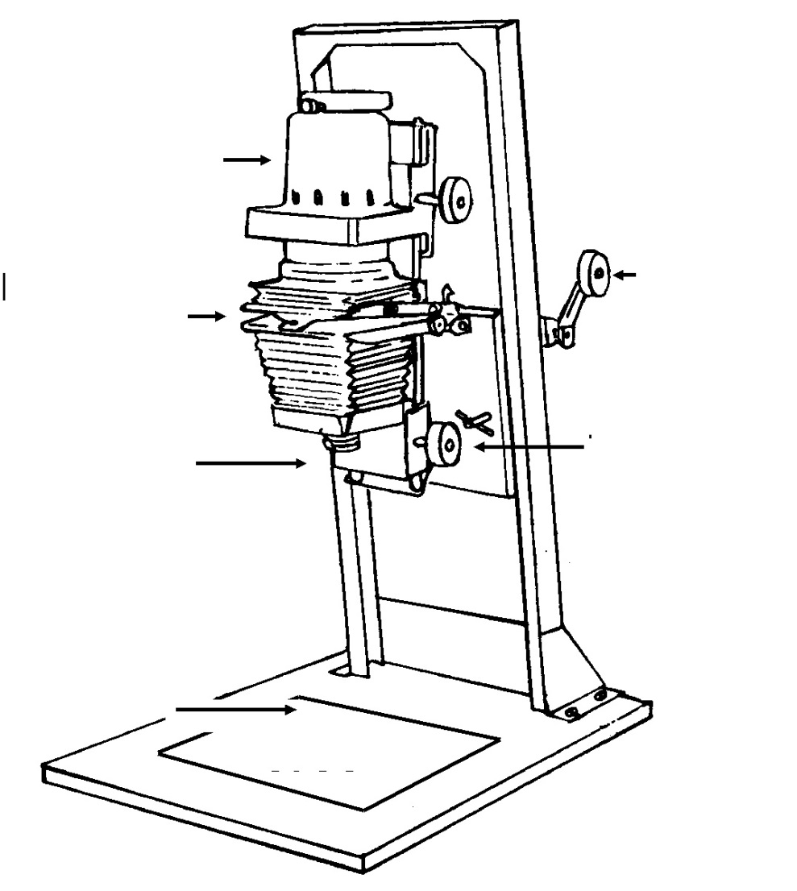
- Using the magazine article and the website diagram, fill in the following diagram with the appropriate terms to label this ENGLARGER:
- What is the emulsion side of your paper?

- Why is the photogram a good place to start in a photography class?

- Describe the basic process of creating a greyscale in the darkroom using the enlarger:

- What does this help you determine in terms of your photogram?

- What is a photogram?

- Describe the basic principle of light and how it affects your paper.

- How does the opacity of an object affect your paper in a photogram?

- Using the video on the website, describe the process of creating a photogram:

- What is interesting about Floris Neusüss’ artwork. How does it differ from a typical photogram?

- Describe Adam Fuss’ unique artistic view on photograms.

