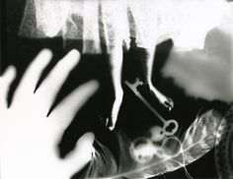
Dream PHOTOGRAM Assignment

CURRICULUM EXPECTATIONS
A1. The Creative Process: apply the creative process to create a photogram
A2. The Elements and Principles of Design: apply elements and principles of design to a photogram for the purpose of self-expression and to communicate ideas relating to a dream you have had
A3. Production and Presentation: produce an art works, using photogram darkroom technology
B1. The Critical Analysis Process: demonstrate an understanding of the critical analysis process by examining, interpreting, evaluating, and reflecting on your own photogram
C1. Terminology: demonstrate an understanding of, and use correct terminology when referring to, elements, principles, and photograms
C2. Conventions and Techniques: demonstrate an understanding of conventions and techniques used
in the creation of the photogram
C3. Responsible Practices: demonstrate an understanding of responsible practices related to visual arts.

Planning Process
- Complete the Photogram note using the videos (website) and the magazine article
- Choose a dream you have had that you would like to represent through your photogram and describe it briefly in your sketchbook
- Choose a variety objects that represent your dream
(a variety of opacities – opaque, transparent and semi-transparent – that will create a variety of values)
- Plan at least three possible arrangements/layouts in your sketchbook (alter the number, combinations and placement of objects in each layout for an 8x10 final print. Consider movement, positive/negative space, spacing
- Conference with your teacher to choose the one photogram you will create to gain your darkroom pass.

Darkroom Process
- Take your pack of paper into the darkroom
- Turn the red light ON, and the fluorescent light OFF
- Remove one piece of paper, and one scrap, from your pack, and return the others by closing the black protective envelope tightly, inserting it upside down inside the white envelope, and closing it carefully within the white envelope
- Use the greyscale activity from the magazine article to determine your exposure time.
- Under the enlarger, lay out your objects carefully on the paper, following the arrangement you have chosen (lay a sheet of glass overtop, if needed, to press the objects down)
- Flick the enlarger light on and off quickly (use timing denoted from your greyscale test
- Carefully remove the objects from your paper
- Develop your paper, using the three tray system
- Rinse your paper and hang your photo to dry
- Repeat the process if contrast level is not optimal
- Mat your final photo for professional display
* submit ALL photo attempts and test strips

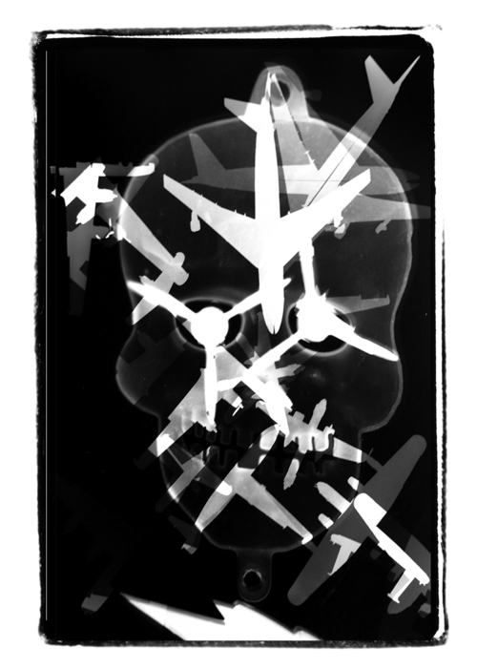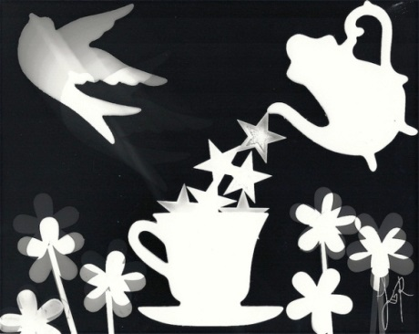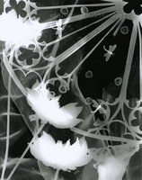

RUBRIC
Student Name:
Criteria:
Level R = none-insufficient Level 1 = limited Level 2 = somewhat Level 3 = considerably Level 4 = thoroughly
(50 - 59%) (60 - 69%) (70 - 79%) (80 - 100%)

Knowledge and Understanding (Understanding of concepts, elements, principles, meaning and significance)
• Demonstrates an understanding of what a photogram is (photogram note questions)  • Demonstrates an understanding of paper development | R 1 2 3 4  R 1 2 3 4 | overall mark for category:  /20

Thinking and Inquiry (Planning & Process; Creative thinking skills & processes, critical analysis)
Planning & Process  • evidence of thorough proposal/rough drafts/ preliminary planning, documented (in sketchbook)  *three layouts/arrangements and dream representations  • effective teacher-conferencing in a timely manner  • your final work was prepared on time for class critiques, peer feedback  Problem Solving  • The problem of creating a successful arrangement  • The problem of choosing objects of various opacities  • The problem of exposing your paper to the correct amount of light (exposure) (test strip and retries)  • The problem of developing the photo on your paper (retries if necessary) | R 1 2 3 4  R 1 2 3 4  R 1 2 3 4  R 1 2 3 4  R 1 2 3 4  R 1 2 3 4  R 1 2 3 4 | overall mark for category:  /70

Communication (The conveying of meaning through various forms; communication of intended message expression/organization of ideas)
The completed rubric answers:  • The rubric questions have been thoroughly answered and were properly submitted with your completed assignment with attention to details and thoughtful, insightful answers.  • Dream representation is creative and interesting | R 1 2 3 4  R 1 2 3 4 | overall mark for category:  /20

Application (The use and knowledge to make connections within and between various contexts; final product, composition, creativity)
Foundations: Responsible Practices.  • throughout the creation of this piece you demonstrated responsible studio practice by: Maintaining a clean, respectful workspace; Consistent, proper, safe materials usage; Not wasting/losing materials/tools/equipment; Responsible, ethical digital citizenship.  Application:  • Final Arrangement is interesting, creative and keeps the viewer’s eye moving around the piece  • Photo development is balanced and effective  • Final print is clean, professional (free of wrinkles, fingerprints, etc.)  • Matting is professional and accurate (all portions included) | R 1 2 3 4  R 1 2 3 4  R 1 2 3 4  R 1 2 3 4  R 1 2 3 4 | overall mark for category:  /50
Rubric Questions:
*To be typed or written on a separate sheet. Each question should be a full paragraph
(minimum 5 sentences each)
- What objects did you choose to represent your dream and why?
- Describe how the light reacted with the paper with the different objects and what was interesting about these observations?
- Give your piece a title. What is the title and why did you choose it?

