Line Techniques Assignment

- Bring an object from home that interests you visually. Choose something that has a variety of planes, where the light will hit, to intensify the values you see.
You will be creating four images, focusing and framing different parts of the same object.

- Sketch out (in your sketchbook) a minimum of 6 frames as options for your final images.

- Conference with your teacher to choose your croppings.

- With focus and precision, draw your object in your four frames, paying close attention to the full value scale visible and the direction of the light hitting your object.

Each frame should utilize a different drawing technique:
- Continuous value
- Stippling
- Cross-hatching
- Hatching
Within each frame, consider the placement, cropping and focus of your object. Each frame should be unique and interesting.
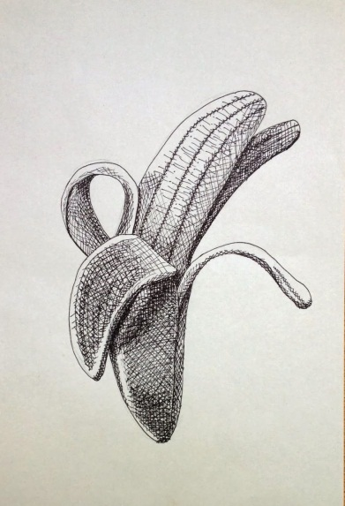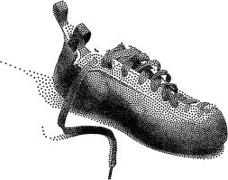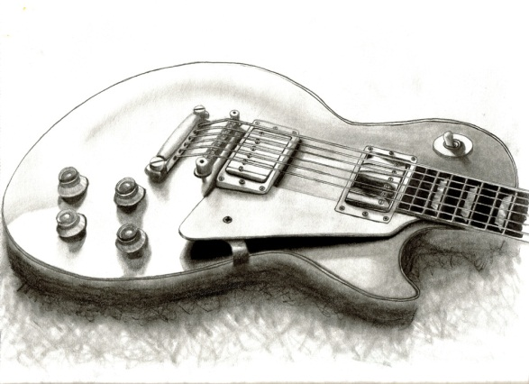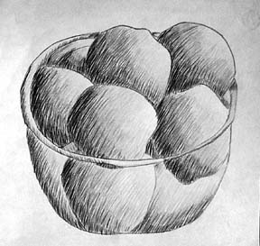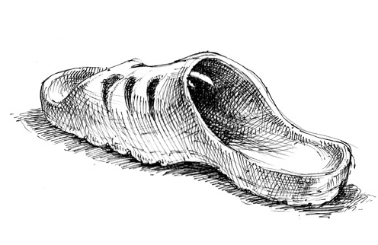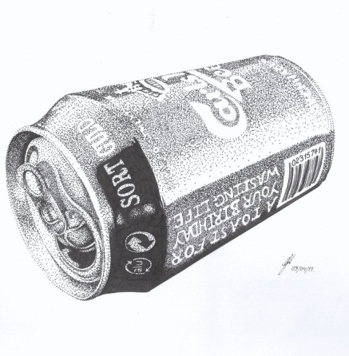
/145 RUBRIC Line Techniques Student Name:

Criteria:
Level R = none-insufficient Level 1 = limited Level 2 = somewhat Level 3 = considerably Level 4 = thoroughly
(50 - 59%) (60 - 69%) (70 - 79%) (80 - 100%)

Knowledge and Understanding (Understanding of concepts, elements, principles, meaning and significance)
• Demonstrates an understanding of the four different line techniques (what are they?)  • Demonstrates an understanding of layout and cropping (interesting, varied)  • Demonstrates an understanding of light source in relation to shading (use one!)  • Demonstrates an understanding of the value scale (do you understand what value is?)  • Demonstrates an understanding of no contour drawing (no outlines) | R 1 2 3 4  R 1 2 3 4  R 1 2 3 4  R 1 2 3 4  R 1 2 3 4 | overall mark for category:  /25

Thinking and Inquiry (Planning & Process; Creative thinking skills & processes, critical analysis)
Planning & Process  • evidence of thorough brain–storming, preliminary planning, documented  (in sketchbook)  • teaching conferencing was completed and on time | R 1 2 3 4  R 1 2 3 4 | overall mark for category:  /10

Communication (The conveying of meaning through various forms; communication of intended message expression/organization of ideas)
The completed rubric answers:  • The rubric questions have been thoroughly answered and were properly submitted with your completed assignment.  • The rubric answers demonstrate attention to details and thoughtful, insightful answers. | R 1 2 3 4  R 1 2 3 4 | overall mark for category:  /10

Application (The use and knowledge to make connections within and between various contexts; final product, composition, creativity)
Foundations: Responsible Practices.  • throughout the creation of this piece you demonstrated responsible studio practice by: Maintaining a clean, respectful workspace; Consistent, proper, safe materials usage; Not wasting/losing materials/tools/equipment; Responsible, ethical digital citizenship.  Application:  • Object chosen is interesting and useful in providing a variety of croppings  • Professional presentation of the final product (clean, unwrinkled paper)  • Full spectrum of value scales are created through drawing techniques  • Smooth transitions are used in the continuous value scale  • Stippling is even, consistent and controlled  • Cross-hatching is even, consistent and controlled  • Hatching is even, consistent and controlled  • Graphite use/technique is appropriate for each drawing style  • Layouts/croppings are interesting, varied and demonstrate an effective use of space  • Contours of object are effectively created, without the use of contour lines  • Light source is accurate, consistent and well depicted | R 1 2 3 4  R 1 2 3 4  R 1 2 3 4  R 1 2 3 4  R 1 2 3 4  R 1 2 3 4  R 1 2 3 4  R 1 2 3 4  R 1 2 3 4  R 1 2 3 4  R 1 2 3 4  R 1 2 3 4 | overall mark for category:  /60
RUBRIC QUESTIONS: * Answer these questions on a different piece of paper to allow yourself space to fully discuss.
- How did you alter the use of your pencil to create different drawing techniques
- Which line technique do you prefer and why?
- What did you find challenging about this assignment and how did you overcome it?

