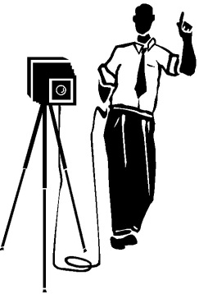
History and Introduction to Photography
PRE-VIEWING (alone or with a partner)

List all the places you see photography used:

What types of cameras do you know exist?

How often do you take photos?

What do you take photos of? (subject matter)

Why do you take photos? (purpose)

VIEWING NOTES

In the _____th century, the Arab scientist __________ developed the idea of using the ___________ _______________: the idea of using a _________ room or box with a single small _________ that let __________ through. This would project the _________ from the world outside onto the wall inside.

During the ________________, in the 15th and 16th centuries, artists like Leonardo Da Vinci used this method to introduce _______ scenes onto a ________ plane so that they could copy things like perspective more easily.

In 1724, Johann Heinrich Schulz discovered that exposing certain _________ compounds to light altered their appearance and left ___________ wherever the light touched. Essentially, Schultz found a way to _____________ images that Alhazan was able to project, but only for a little while. Shcultz’s images ______________ soon after he had made them.

It wasn’t until 1839 that people figured out how to project images onto light _____________ surfaces that would __________ the images after exposure. And thus, photography was born.

Two inventors fought for the best way to make photos: British scientist, Henry Fox Talbot, whose Calotype process used _________ and allowed many copies to be made from a single ____________. The other inventor Louis DaGuerre was an _____________ and chemist from France. He developed something called a DaGuerrotype which used a silvered ______________ and which produced a ________________ image. But, the DaGuerrotype could only make _______________ images, so copies had to be made by taking another photo. In the end, the __________________ won out, mostly because the government made it freely available to the public.

This process still required a full ___________________ at the location of the photo shoot. The early processes had extremely long ________________ times. To get a good photo, you would have to stand perfectly ____________ for up to 2 minutes. This led to developments of inventions like the _____________ ______________, a wire frame that would hide behind you while supporting your head. This is also why you don’t see people ___________ in early photographs. It’s not that life was that bad, it was just hard to keep a steady grin for more than a few seconds, so people opted for a straight face look.

George Eastman, in the 19th and 20th centuries, believed that ________________ should have access to photography, so tried to achieve a _________ plate photographic process. This would allow exposed ____________ to be stored and developed __________ at a more convenient place. Eastman eventually discovered _____________ _____________ films that would fit in hand held ________________ cameras. These cameras sold by the millions under the tagline,
“You push the button ….. we do the rest”.

It is now estimated that over 380 _____________ photographs are take each year. That’s more photographs each _______ than were taken in the first __________ years that photography was invented.

Say Cheese

