Hero Reduction
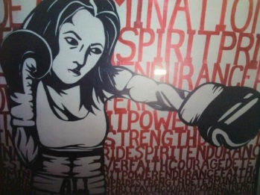 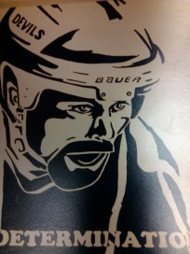 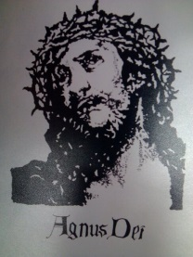 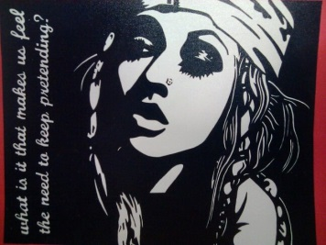
Your task:

To complete a black & white reduction painting which visually and verbally makes a statement about someone you consider to be a hero.

1) Preliminary work:
• In your sketchbook define the word hero. What does it mean? What does it mean to you? Who do you identify with as being a hero? Why?
• Jot down some ideas about a person you could use to create a reduction of, whom you feel is a hero.
• Jot down several single words which you feel sum up that person’s key heroic strengths.
• Begin to find a picture you could use of that person for your reduction.

2) Sketches for the reduction:
• Obtain a copy of your picture of your hero. TRACE over the image, or use a DUPLICATE COPY to define the reduction. A simple way to do this is to take a black marker or black pen and fill in your shadows. Leave your highlights white. You may want to do several of these preliminary trials until you come up with the reduced values that most effectively capture your image. Do these sketches in your sketchbook.

3) The reduction:
• Transfer the image onto a sheet of bristol board and paint your reduction. One or more of the words you used to describe your hero should be included.

You will be evaluated on:
Neatness, overall composition, effective job at reducing the key features & images into basic tones, how well the word you choose emphasizes the heroic strength of your person, etc.
NAME: _____________________________________
Knowledge and Understanding (Understanding of concepts, elements, principles, meaning and significance)
• Demonstrates an understanding of reduction style  • Demonstrates an understanding of typography | R 1 2 3 4  R 1 2 3 4 | overall mark for category:  /20

Thinking and Inquiry (Planning & Process; Creative thinking skills & processes, critical analysis)
• Assignment is submitted on time  • Preliminary Work | R 1 2 3 4  R 1 2 3 4 | overall mark for category:  /20

Communication (The conveying of meaning through various forms; communication of intended message expression/organization of ideas)
• Image and text communicate a strong message | R 1 2 3 4 | overall mark for category:  /10

Application (The use and knowledge to make connections within and between various contexts; final product, composition, creativity)
Application:  • Clean and professional final product  • Precision Painting  • Accurate/effective reduction  • Effective layout  • suitable font style | R 1 2 3 4  R 1 2 3 4  R 1 2 3 4  R 1 2 3 4 | overall mark for category:  /50

