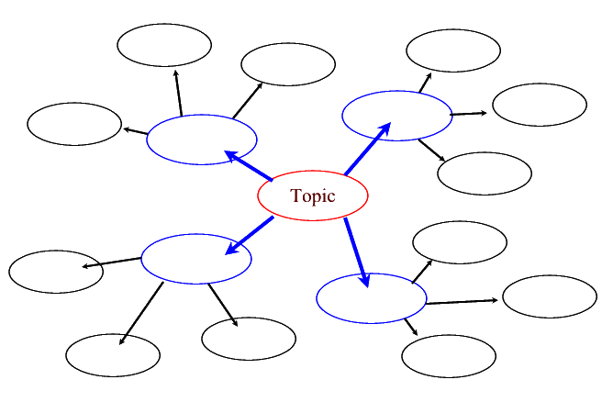
Fill in the following chart with 4 of your pet peeves, and 3 supporting ideas for why they irk you…. Feel free to include drawings as well as text.
Keep your topics appropriate!
Take your 1st choice of pet peeve, the one that really gets under your skin, and write a well-structured, grammatically correct, paragraph expressing your opinion. Your language may be casual, but educated and appropriate!
________________________________________________________________________________________________________________________________________________________________________________________________________________________________________________________________________________________________________________________________________________________________________________________________________________________________________________________________________________________________________________________________________________________________________________________________________________________________________________________________________________________________________________________________________________________________________________________________________________________________________________________________________________________________________________________________________________________________________________________________________________________________________________________________________________________________________________________________________________________________________________________________________________________________________________________________________________

