Famous/Significant Photos in History
Curriculum Expectations
A1. The Creative Process: apply the creative process to create a multimedia presentation
B1. The Critical Analysis Process: demonstrate an understanding of the critical analysis process by examining, interpreting, evaluating, and reflecting on your photograph and artist
B2. Art, Society, and Values: demonstrate an understanding of how your photo reflects the society in which they were created, and of how they can affect personal values;
C1. Terminology: demonstrate an understanding of, and use correct terminology when referring to, elements, principles, and other components related to your photo
C2. Conventions and Techniques: demonstrate an understanding of conventions and techniques used in the creation of visual art works;
C3. Responsible Practices: demonstrate an understanding of responsible practices related to visual arts.

- Choose one of the photos from the list (images) provided on the website. *First come first serve
- Reflect on your photo
  - Visually (ANALYSE)
    - Thoroughly discuss elements and principles of design and their impact on the photo
ie:
      - Where is your eye drawn to and why
      - What movement exists in the photo and how does it lead the eye
    - Thoroughly discuss rules of composition and their impact on the photo
    - Thoroughly discuss photo framing and its impact on the photo
  - Personally (INTERPRET & JUDGE)
    - How do these elements and principles contribute to the photo
    - Discuss mood, message, reaction, etc. What do you think?
    - Why do you think this is a significant/important photo?
- Research your photo thoroughly and provide the following information (DESCRIBE):
  - Photographer
  - Title (if one exists)
  - Date and location the photograph was taken
  - Social/historical circumstances
  - Social/historical impact (some of this may be interpretation)
  - Etc.
- Present your photo, findings and reflections to the class in a 5-7 minute multimedia presentation.
- PowerPoint
- Prezi
- Google presentation
- Etc.
Include text, quotations, and images as well as other media such as video clips and/or music.
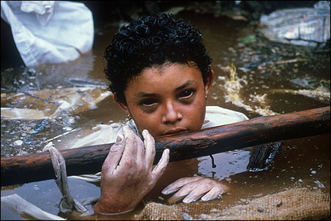 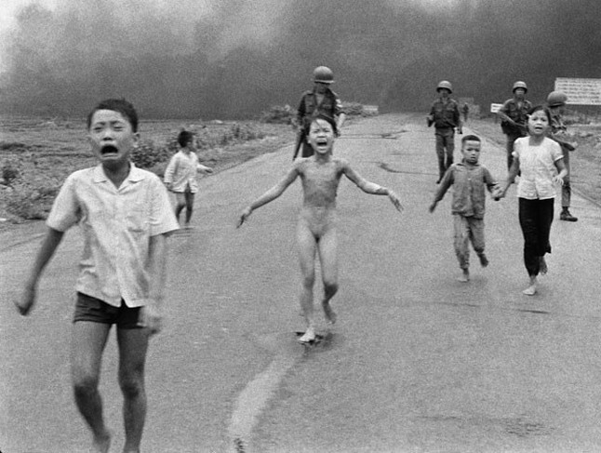

AWQ 3O - Significant Photos Assignment
Student Name:
Criteria:
Level R = none-insufficient Level 1 = limited Level 2 = somewhat Level 3 = considerably Level 4 = thoroughly
(50 - 59%) (60 - 69%) (70 - 79%) (80 - 100%)

Knowledge and Understanding (Understanding of concepts, elements, principles, meaning and significance)
• Demonstrates thorough research findings that represent all components relevant to the photo and its context (DESCRIBE)  • Demonstrates a thorough understanding of the use of Elements and Principles in the photo (ANALYZE)  • Demonstrates a thorough understanding of the use of Rules of Composition in the photo (ANALYZE)  • Demonstrates a thorough understanding of the use of Photo Framing in the photo (ANALYZE) | R 1 2 3 4  R 1 2 3 4  R 1 2 3 4  R 1 2 3 4 | overall mark for category:  /40

Thinking and Inquiry (Planning & Process; Creative thinking skills & processes, critical analysis)
Planning & Process  • research is gathered from a wide variety of sources and works sited list is provided for all photos and information gathered (5+)  Critical Analysis  • Personal reflection on photo is thorough and insightful (INTERPRET, DECIDE & JUDGE) representing an in-depth understanding of the photo and its relevance | R 1 2 3 4  R 1 2 3 4 | overall mark for category:  /10  /30  /40

Communication (The conveying of meaning through various forms; communication of intended message expression/organization of ideas)
Multimedia components communicate a mood consistent with the photo’s relevance  (variety included ie music, video, photos)  The completed rubric answers:  • The rubric questions have been thoroughly answered and were properly submitted with your completed assignment and demonstrate attention to details and thoughtful, insightful answers.  • Oral presentation skills are professional and well-rehearsed  Application:  • Final product represents a thorough understanding of chosen presentation software and is effectively laid out and organized (clear and visually impactful) | R 1 2 3 4  R 1 2 3 4  R 1 2 3 4  R 1 2 3 4 | overall mark for category:  /40
Rubric Questions:
- Why did you choose the photo for this project? What initially drew you to it?
- What did you find most interesting about your photo, once research was completed?
- What multimedia components did you choose to add to your presentation and how do you believe they represented the mood of the photo you researched?
