ENG 2DI The Purpose of Literary Devices

Authors choose to employ literary devices within a piece of writing to keep their readers interested and to add beauty to the writing. By making personifications, allusions, metaphors, etc. the writing becomes rich and meaningful and evokes strong feelings in the readers.
Literary devices are the tools and techniques of language that authors use to add layers of meaning. Rather than simply stating the facts, authors hint at and disguise some of it, so that the reader must figure things out for him/herself (showing not telling).

Fill in the chart below as we go through the PowerPoint:

Device | Purpose(s)
Alliteration

Personification

Simile

Metaphor

Onomatopoeia

Now, write your own! Choose an noun to place in the centre of your flower. (the flower is unrelated to your topic; it is simply a shape with the accurate number of compartments) In each of the petals, write a device to deepen the meaning of the noun you have chosen. Keep the theme focused and cohesive.
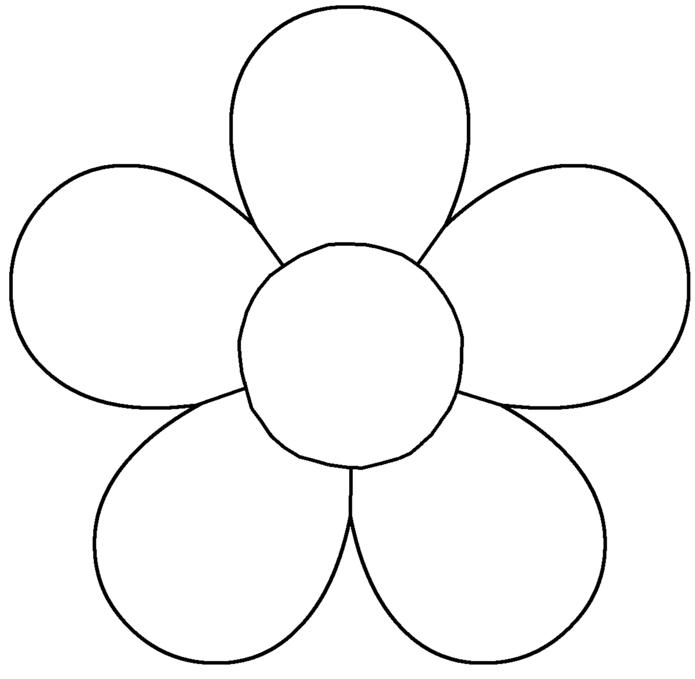

Take each of the devices you have written in your petals and turn them into a cohesive paragraph describing your noun:
________________________________________________________________________________________________________________________________________________________________________________________________________________________________________________________________________________________________________________________________________________________________________________________________________________________________________________________________________________________________________________________________________________________________________________________________________________________________________________________________________________________________________________________________________________________________________________________________________________________

