Elements & Principles Posters
Class Activity

In pairs, choose one of the following Elements or Principles:

Elements Principles
Line Pattern
Shape Contrast
Colour Emphasis
Value Balance
Texture Size/Proportion
Space Harmony/Unity
Rhythm/Movement

Create a poster to display your Element or Principle. Include a title, a variety of artistic purposes your Element or Principle serves, and photographic examples of each.
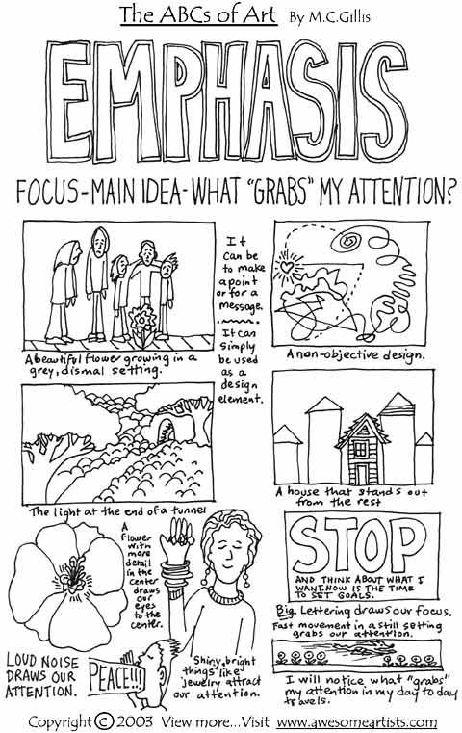
You will present your poster to the class and it will go on display for reference throughout the term.

