Drawing Techniques
Try each of the following drawing techniques in the box provided:
TECHNIQUE EXAMPLE YOUR RECREATION ARTISTIC EXEMPLAR
Stippling |  |  |  |  | 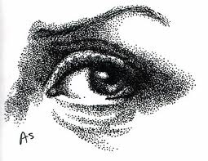
Hatching |  |  |  |  | 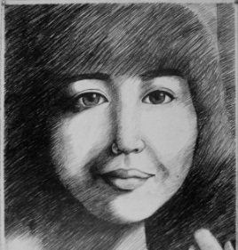
Cross Hatching |  |  |  |  | 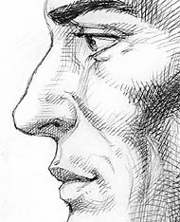

Value Scale using Line….
Lightest (1) (example – cross hatching) Darkest (6)

Stippling
Hatching
Cross Hatching
Scribbles
Circles
Zigzags
A combination of any two techniques
Tonal
Continuous Value Scale
Continuous

