Double Exposure Assignment
Curriculum Expectations
A1. The Creative Process: apply the creative process to create an effective double exposure print
A2. The Elements and Principles of Design: apply elements and principles of design to create a double exposure for the purpose of self-expression
A3. Production and Presentation: produce a double exposure using two pieces of film in the enlarger
B1. The Critical Analysis Process: demonstrate an understanding of the critical analysis process by examining, interpreting, evaluating, and reflecting on the photo
C1. Terminology: demonstrate an understanding of, and use correct terminology when referring to, elements, principles, and other components related to your photo
C2. Conventions and Techniques: demonstrate an understanding of conventions and techniques used in the creation of the double exposure
C3. Responsible Practices: demonstrate an understanding of responsible practices related to visual arts.

In photography and cinematography, a multiple exposure is the superimposition of two or more exposures to create a single image, and double exposure has a corresponding meaning in respect of two images. The exposure values may or may not be identical to each other.

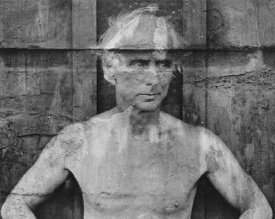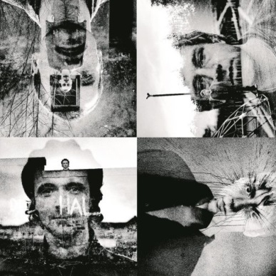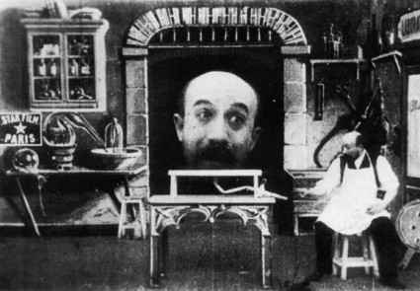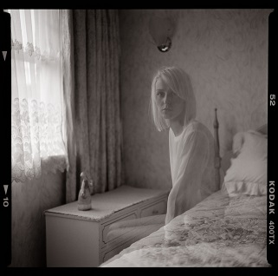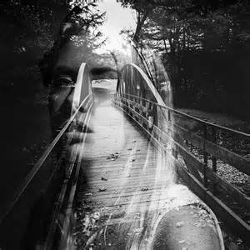

Step One: In your sketchbook, plan two images you will superimpose over top of eachother. It is very important you line things up exactly, so you get the result you are looking for!
Step Two: Conference with me with your drawings

Step Three: Take your two photos.
Step Four: Overlay your negatives in the enlarger and expose on a test strip to determine your ideal exposure time

Step Five: Expose your full paper, with the double negatives, to create your final image
Step Five: Develop, mount and display your final photograph with date, signature and title

RUBRIC
Student Name:
Criteria:
Level R = none-insufficient Level 1 = limited Level 2 = somewhat Level 3 = considerably Level 4 = thoroughly
(50 - 59%) (60 - 69%) (70 - 79%) (80 - 100%)

Knowledge and Understanding (Understanding of concepts, elements, principles, meaning and significance)
• Demonstrates an understanding of what a double exposure is  • Demonstrates an understanding of layout/composition  • Demonstrates an understanding of film development  • Demonstrates an understanding of photo enlarging and development | R 1 2 3 4  R 1 2 3 4  R 1 2 3 4  R 1 2 3 4 | overall mark for category:  /40

Thinking and Inquiry (Planning & Process; Creative thinking skills & processes, critical analysis)
Planning & Process  • evidence of thorough proposal/rough drafts/ preliminary planning, documented (in sketchbook)  *two superimposed images  • effective teacher-conferencing in a timely manner  • your work was prepared on time for class critiques, peer feedback  Problem Solving  • The problem of creating a successful arrangement  • The problem of developing the correct exposure (test strip) | R 1 2 3 4  R 1 2 3 4  R 1 2 3 4  R 1 2 3 4  R 1 2 3 4 | overall mark for category:  /50

Communication (The conveying of meaning through various forms; communication of intended message expression/organization of ideas)
The completed rubric answers:  • The rubric questions have been thoroughly answered and were properly submitted with your completed assignment and demonstrate attention to details and thoughtful, insightful answers.  • Artistic vision with double exposure is interesting, creative and unique | R 1 2 3 4  R 1 2 3 4 | overall mark for category:  /20

Application (The use and knowledge to make connections within and between various contexts; final product, composition, creativity)
Foundations: Responsible Practices.  • throughout the creation of this piece you demonstrated responsible studio practice by: Maintaining a clean, respectful workspace; Consistent, proper, safe materials usage; Not wasting/losing materials/tools/equipment; Responsible, ethical digital citizenship.  Application:  • Double exposure is balanced and effective  • Layout/composition is effective  • Photo development is balanced and effective  • Final print is clean, professional and professionally mounted (free of wrinkles, fingerprints, etc.) | R 1 2 3 4  R 1 2 3 4  R 1 2 3 4  R 1 2 3 4  R 1 2 3 4 | overall mark for category:  /50

Rubric Questions:
*To be typed or written on a separate sheet. Each question should be a full paragraph
(minimum 5 sentences each)
- Describe your artistic vision with this double exposure image.
- Discuss the effectiveness of the final piece.
- Give your piece a title. What is the title and why did you choose it?

