|  |
| --- |
| **Technical Design Portfolio Assignment** |

**TASK 1:** (*I, P & Y)Using the creative retelling of story, you will create a Set Design (in Single Point Perspective) that could be used in a staged production of your chose.

* Brainstorm an overall vision for the set design. You have to make choices on the **environment** you want to create (ie. living room, a forest, aboard a ship, etc); the **mood** and **style** (ie. dark, gritty, etc); the **locale** and **period** (ie. Medieval period, modern time, etc); **realistic vs. non-realistic** setting; and your **overall image**. Then, create a **Pinterest Board** by find and compile a **collage (pinterest board)** of pictures that will influence your design.
* Using the Single Point Perspective technique learned in class, draw a small pencil version of your set design on 8.5 x 11 paper. Base your design around some of the pictures from your collage.
* Scan your drawing into the computer and use Photoshop to draw a grid over your set design (8.5 x 11 copy).
* On large Bristol board, using the gridding techniques learned in class, redraw your image on a large scale. This final image **must be in colour, using paint or pencil crayon** and must be a design that could be used on a stage (actors need to be able to move around on stage, different levels are often needed).
* Include a list of set pieces and props, identifying (using proper stage terminology, ie Stage Left) where each piece is located on the stage

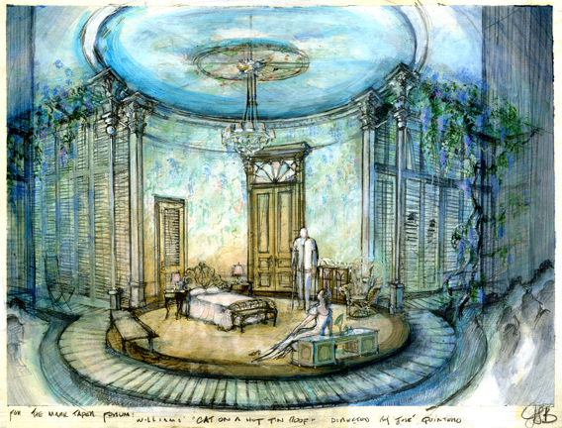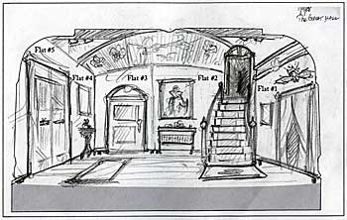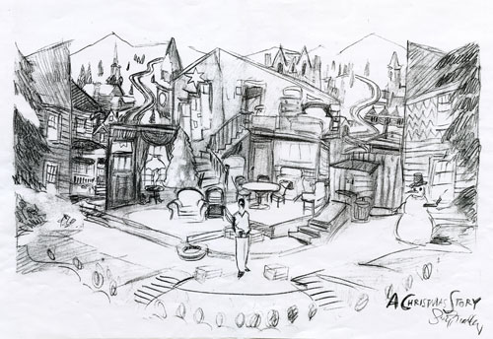

**TASK 2:** P students choose ONE; Y students choose TWO of the following tasks to add to your portfolio

1. **Lighting Design**

* Create a **Pinterest Board** to gather information to create a **full lighting design** for your set
* Include a full colour **light plot** –a plan view of the stage showing the set pieces, where each lighting instrument is located, and the pool or spot the light creates. Represent the fixture type (Ellipsoidal, Fresnel, Scoop, etc) with the appropriate symbol.
  + This can be hand drawn or created on Photoshop
* Fill out the **Theatre Lighting Design sheet** to **explain and justify** your design choices

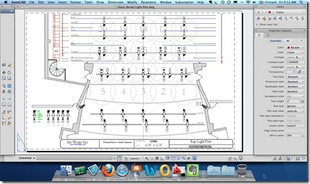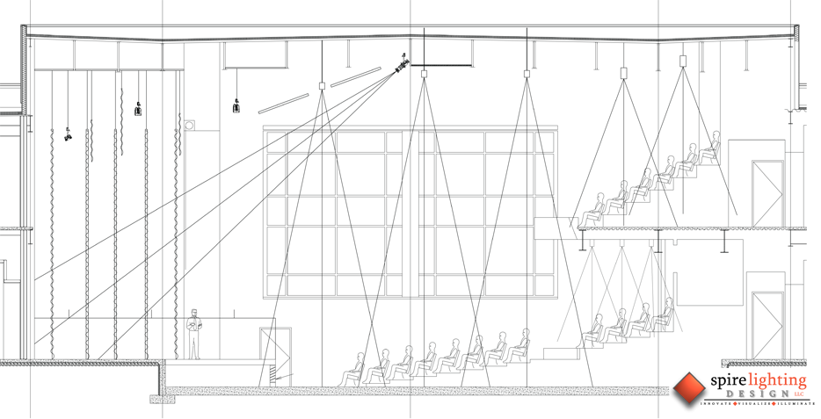

**2. Costume Design**

* Create a **Pinterest Board** to gather information to create a **full costume** for a character
* Include a costume **sketch** for one character
* You can use the male and female **template**s provided or create your own original renderings.
* Make **choices** based on what best suits your characters.
* Outfit your characters from **head to toe** (include accessories, clothing, shoes, jewellery, etc.)
* Your final sketches must be **coloured.**
* Include the **costume design note** on **design and justifications**

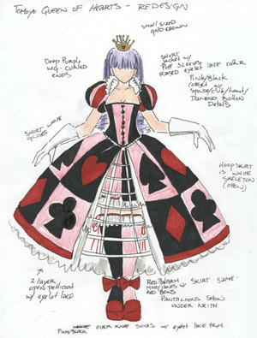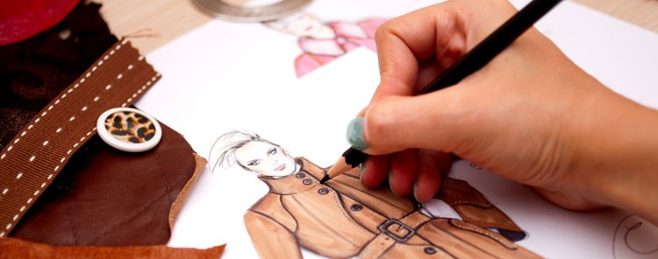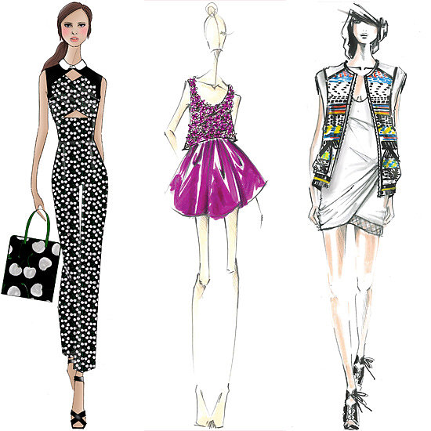

**3. Makeup and Hair Design**

* Create a **Pinterest Board** to gather information to create **full makeup and hair** for a character
* Include a hair and makeup **sketch** for one character
* You can use the male and female **template**s provided or create your own original renderings.
* Make **choices** based on what best suits your characters.
* include all aspects of face, prosthetics, hair design and additions as well as head accessories
* Your final sketches must be **coloured.**
* Include the **hair and makeup note** on **design and justifications**

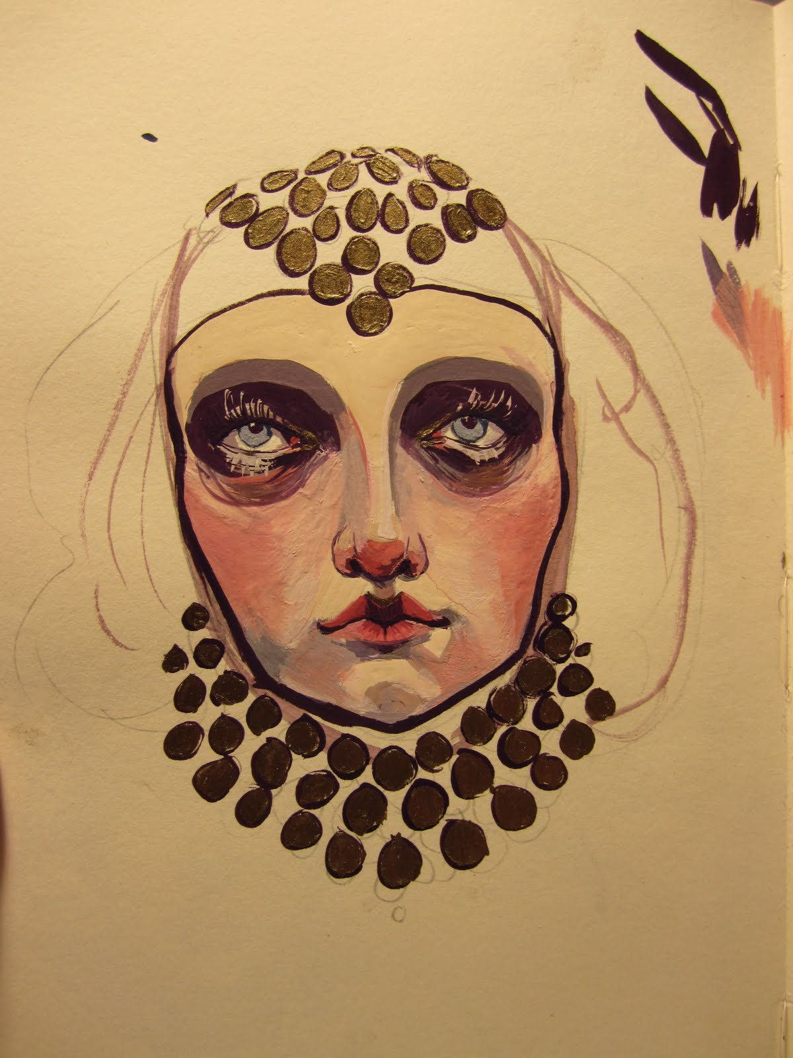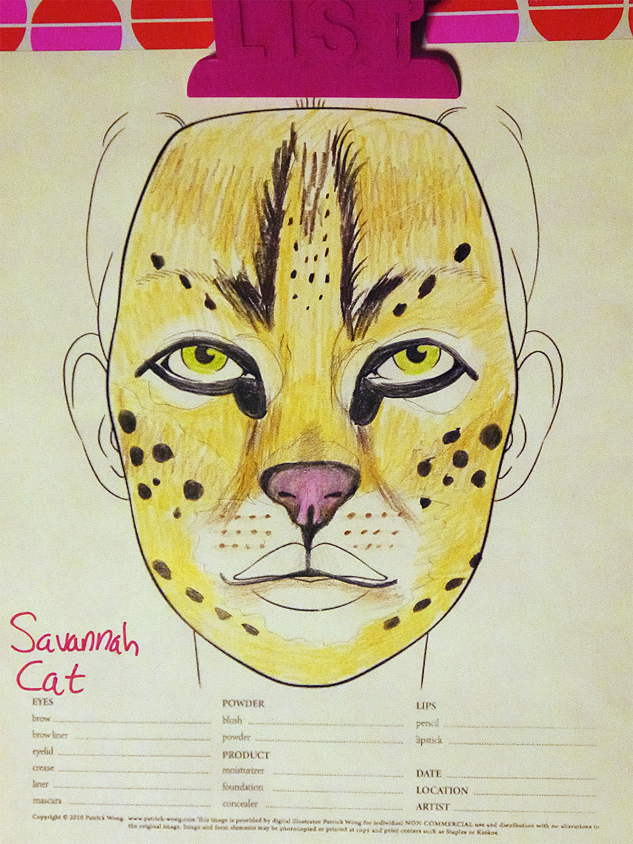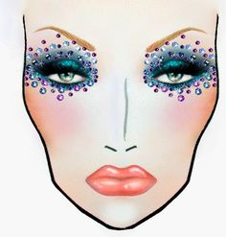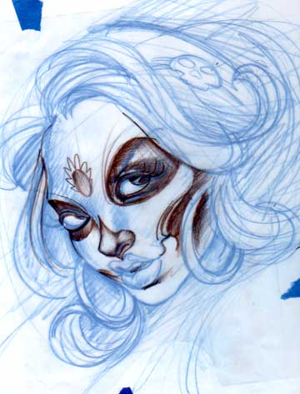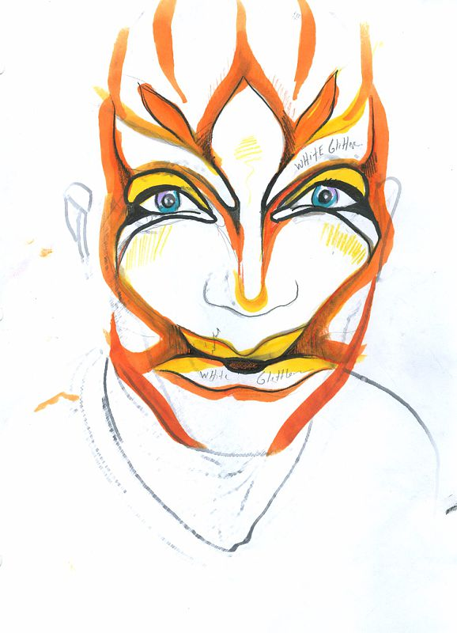

***\* When gathering inspirational images for each componenet (Pinterest Boards), the images can be literal (actual hair, makeup, stage lighting, shoes, etc.) or simply inspirational (paintings, photos, lanscapes, music, etc.) You are creating a mood, and for instance, a photograph of a rainy day may inspire you for a makup theme. Use your imagination.***RUBRIC

|  |  |  |  |  |  |
| --- | --- | --- | --- | --- | --- |
| **Criteria:** | **4** | **3** | **2** | **1** | **R** |
| **Knowledge**  **A 4.2**  **Renderings are all formatted correctly (1 point perspective)**  **C 1.2**  **Appropriate terminology throughout written portions (lighting, costumes, set and makeup) demonstrating knowledge of theatre production.** | One point perspective is completely accurate and shows an advanced understanding of the drawing techniques.  All terminology is accurate and demonstrates an advanced understanding of theatre production through writing. | One point perspective is accurate for the most part and shows a good understanding of the drawing techniques.  Most terminology is accurate and demonstrates a good understanding of theatre production through writing. | Some parts of the one point perspective are accurate; shows some understanding of the drawing techniques.  Some terminology is accurate. Some knowledge of theatre production is evident through writing. | Limited parts of the one point perspective are accurate; drawing shows limited understanding of the drawing techniques.  Limited accurate terminology used. Limited knowledge of theatre production evident through writing. | One point perspective is not accurate, too many errors interfere.  Terminology used throughout the writing is incorrect or no specific terms have been included throughout the writing. |
| **Thinking**  **A 1.1**  **(Design Research)**  **❑ Pinterest Boards**  **❑ Original Movie Note**  **A 1.2**  **(Brainstorming/ Planning Sheets)**  **❑ Story Planning**  **❑ Set planning/ Set Sketch**  **❑Make up/ Hair/ Lighting Planning Sheet(s)**    **B 1.2**  **Artistic justifications (make-up/costumes/ lighting) are accurate, relevant and meaningful.** | Research demonstrates thorough design planning.  All process work is complete and demonstrates an exceptional amount of brainstorming.  Artistic justifications demonstrate very advanced thinking about the overall design. | Research demonstrates good design planning.  Most process work is complete and demonstrates a good amount of brainstorming.  Artistic justifications demonstrate good thinking about the overall design. | Research demonstrates some design planning, more research is needed.  Some process work is complete. More attention to brainstorming would improve the final product.  Artistic justifications demonstrate some thinking about the overall design. | Limited research; more research is needed to improve design plan.  Limited process work is complete. Much more attention to brainstorming is necessary.  Artistic justifications demonstrate limited thought about the overall design. | No research was completed.  No process work is complete. No planning has been demonstrated.  No artistic justifications have been made. Artistic justifications are incomplete/ irrelevant/ inaccurate. |
| **Communication**  **A 2.1**  **Creating mood/atmosphere (degree of detail through elements and principles of design)** | Lighting/ costumes convey an exceptional degree of atmosphere/ mood through many specific design details. | Lighting/ costumes convey a high degree of atmosphere/ mood through specific design details. | Lighting/ costumes convey some degree of atmosphere/ mood through some specific design detail. | Lighting/ costumes convey a limited degree of atmosphere/ mood through limited specific design detail. | Lighting/ costumes are incomplete/ missing or no attempt has been made to create mood/ atmosphere through specific detail. |
| **Application**  **A 2.2**  **Story modification-Integrity maintained of story through an original adaptation**  **A 4.2**  **Professional presentation of finished drawings**  **C 3.2**  **Lab etiquette/ use of class time & materials** | All aspects maintain the integrity of the original story; the adaptation is extremely original  Final products are presented in a highly professional manner.  Excellent responsible practice, use of class time and materials. | Most aspects maintain the integrity of the original story; the adaptation is original for the most part  Final products are presented in a professional manner.  Good responsible practice, use of class time and materials. | Some aspects maintain the integrity of the original story; the adaptation is somewhat original  Final products are presented in a somewhat professional manner.  Adequate responsible practice, use of class time and materials. | Limited aspects maintain the integrity of the original story; the adaptation lacks originality  Final products are presented with limited professionalism.  Limited responsible practice, use of class time and materials. | The original story cannot be identified. No attempt has been made to create an original adaptation.  Final products are missing/ incomplete or lack professionalism.  Unsatisfactory responsible practice, use of class time and materials. |