Design and Technical Production

The highly skilled _____________ people working in design and production, __________, _______________ and _____________ all the physical details of a _______________ (film or TV) environment.
List some of the jobs this includes: ____________________________________________________________________________________________________________________________________________________________________________________________________________________________________
List the Set Designer’s Objectives:
________________________________________________________________________________________________________________________________________________________

Set Designer
  - works with the ______________ and other designers to establish an overall ___________________ for the production and design the stage _____________(and _______________).
  - develop a set of design _________________________________, creating scale _____________________ of the scenery, paint _____________________ and scale _____________________ drawings as part of their communication with other production staff.

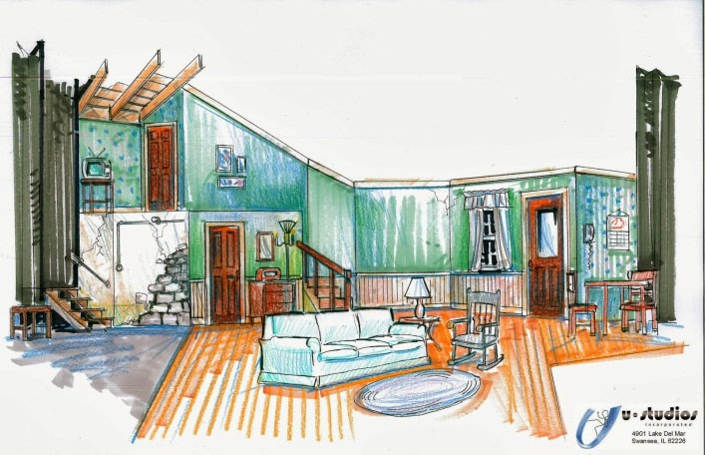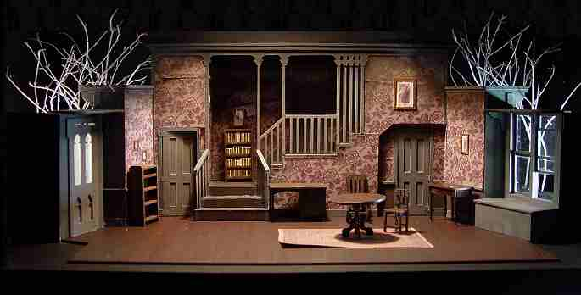

The Theatre Lighting Designer (or ________) works with the director, choreographer, set designer, costume designer, and sound designer to create the _____________, _______________, and ______________ for the production in response to the _______________, while keeping in mind issues of ___________________, ___________________________, and ___________________.

Visibility
- Making the performer ________________ is the most important aspect of lighting
- The lights’ ________________, ________________ and _________ all require very careful consideration.
Setting
- _____________ and other lighting conditions such as a lightning storm, a warmly lit fireplace etc. are recreated on stage, making for a ________________ and more importantly, an ___________________ situation.
Mood/Atmosphere
- Audiences normally connect certain lighting states with certain moods. Happy party atmosphere = ___________________; soft glow from a Fireplace = _____________; and so on.

Composition
The act of painting a ____________

Selective Focus
- Just as it is possible/necessary to make a performer _________, it is possible to make others appear ____________, and ____________ just one person. This ability to use selective visibility is very useful for getting the audience’s attention and focus where you want it.

The basic qualities of light are:
- ______________
- FORM
- ______________
- DIRECTION and
- _______________.

Traditional Lighting Method:
- Goal: general and ________ illumination of the principle acting _______ of the _______.
- Division of ___________ areas into lighting _________.
- Overlapping of ________ to compensate for _____________ characteristics.
- Blending of _______________ colors to achieve __________ light.

Lighting Legend
- Drawings use particular _____________ to indicate the ___________ of lamp/light
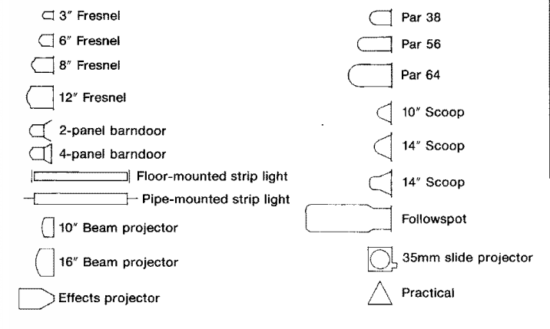
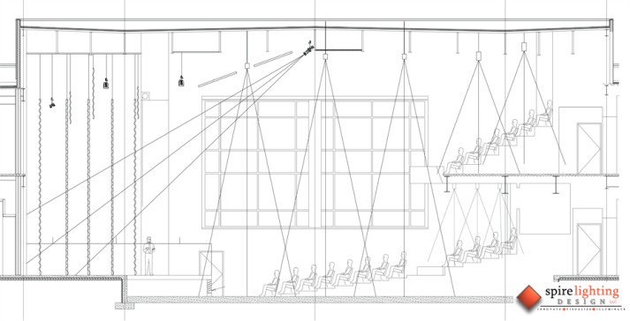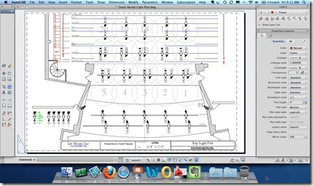
- Drawings show location of _________ as well as the _________________ of light emitting from it.

Costume Design
- The creation and fabrication of ___________ and _______________ for the overall ___________ of a character or performer.
- Functions of Design:
  - Show ________ and _________
  - Establish an ______________
  - Reflect character’s _________, age, personality, __________, style, social and economic status
- Functions of Design:
  - Reinforce metaphor, ___________ or allegorical concept
  - Establish ____________ and atmosphere
  - Create both __________ and unity
  - Establish or clarify character __________
- Costume designers create the _________ of each character by designing _________ and ___________ the actors will wear in performance.
- Depending on their style and complexity, costumes may be ________, bought, _______ out of existing stock or _______. Their designs need to ______ reflect the personalities of the characters in the script.
- Costume Designers:
  - Study the _________________ the story takes place
  - Research in ________________
  - Look in ________________
  - Research Old _______________(people or national geographic)
  - Look at ______________
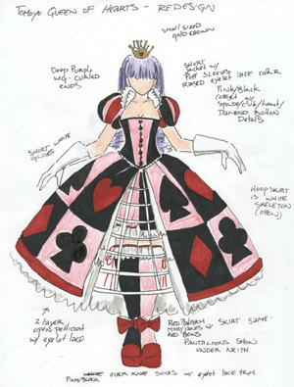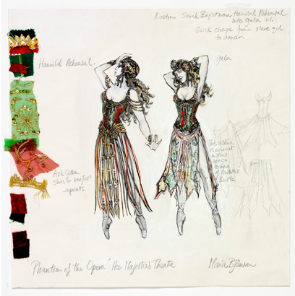

Hair and Makeup
- Theatrical makeup refers to makeup that is used to assist in creating the ____________ of the characters that actors __________ during a theater production.
- Needs to be ________________ to be _________ by the audience
- Needs to _____________ the character, __________ and storyline
- Use darks to ____________(sink back) space, and lights to _________ and bring ___________
- Address all ______ of the ______ including eyes, brows, lashes, lids, lips, cheeks, ears, neck, hair etc.
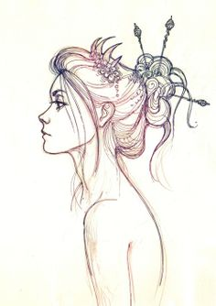
Hair can be real or false (wigs/extensions)
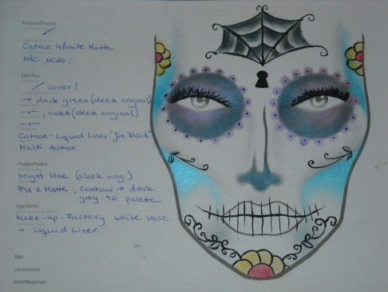
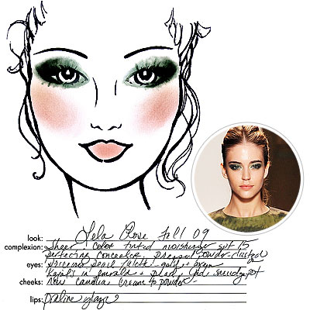
- Include _______ and ______ clarifying details about all aspects of hair and makeup
- Ideally, ___________ and __________ are provided as well

