Darkroom Experimentation
with old negatives * you must have a distinct vision to propose if you wish to take new photos
Curriculum Expectations
A1. The Creative Process: apply the creative process to create a variety of darkroom experimentation photos
A2. The Elements and Principles of Design: apply elements and principles of design to create your photos for the purpose of self-expression and to communicate ideas, information, and/or messages;
A3. Production and Presentation: produce art works, using a variety of darkroom experimentation tools, and techniques
B1. The Critical Analysis Process: demonstrate an understanding of the critical analysis process by examining, interpreting, evaluating, and reflecting on your photos
C1. Terminology: demonstrate an understanding of, and use correct terminology when referring to, elements, principles, and other components related to your photos
C2. Conventions and Techniques: demonstrate an understanding of conventions and techniques used in the creation of darkroom experimentation photos
C3. Responsible Practices: demonstrate an understanding of responsible practices related to visual arts.

Choose a negative you have from a previous project (you are welcome to use someone else’s as well and re-appropriate it for your new artwork, with their permission). Draw at least one proposal for each category and conference with your teacher before proceeding.

- Developer Painting – Project the image onto your photo paper, then rather than immersing your paper in developer, paint it on strategically for artistic effect.
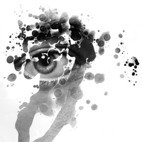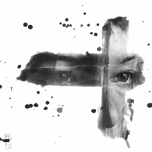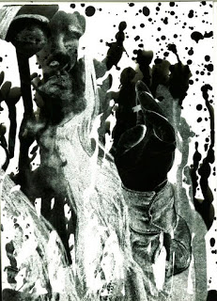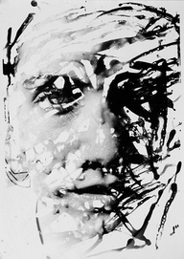
- Silhouette Blocking – create a stencil cutout using opaque paper. Cover a portion of your paper with the stencil prior to exposing it to light under the enlarger. When you expose it, it will block parts of the paper that will not develop.
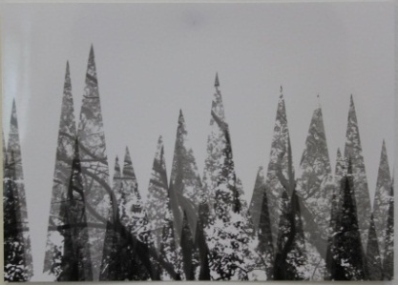 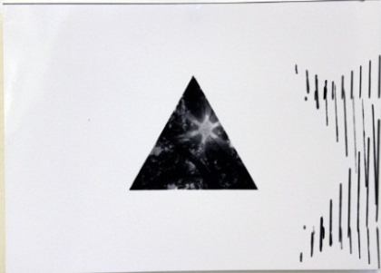 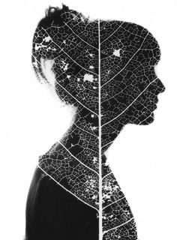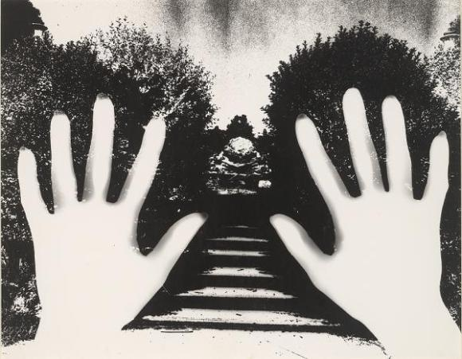
- Distressing Negatives – using a magnifying glass, alter directly on an old negative by using a variety of techniques: scratching (When you scratch on the top/non-emulsion side of the negative, refraction will produce white lines on your print. When you scratch on the bottom/emulsion side of the negative, the scratches will remove emulsion and produce black lines), drawing, burning (carefully under teacher supervision), cutting (x-acto knife), rearranging cut pieces, apply bleach (The bleach removes silver, and requires fixing afterwards, so rinse the negative in water until the yellow stain disappears, and then fix in film strength fixer for 2-4 minutes. If you accidentally overbleached, you can redevelop the negative before fixing.) etc.
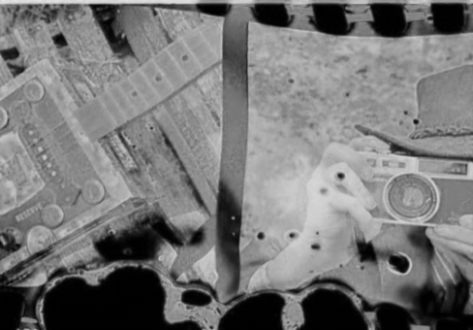 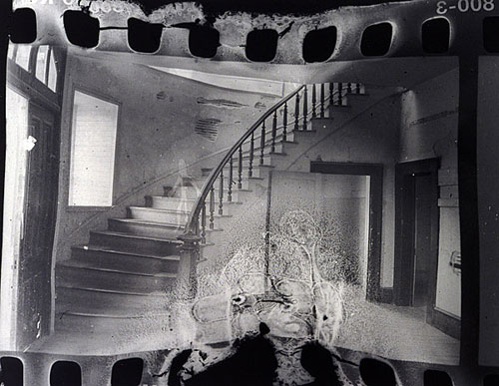
- Photogram and photo enlarging combination – cover your paper with transparent and semi-transparent object. Then, project your negative onto the paper using the enlarger.
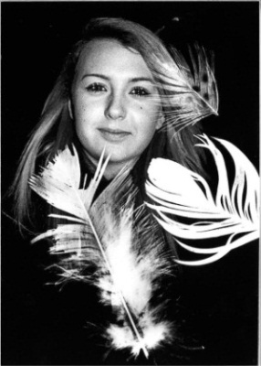 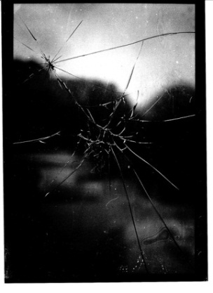 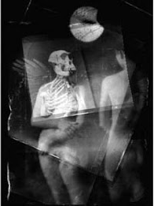 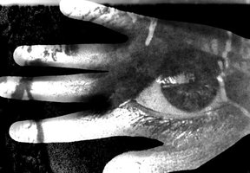
- Word and/or image Superimposition – Photocopy words, or another image, onto acetate (overhead) paper. Place the overhead over your photography paper before exposing it under the enlarger. The words/image will block the light and prevent the paper from being exposed in those areas.
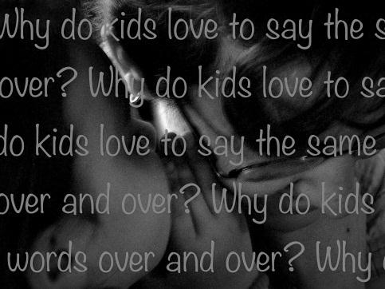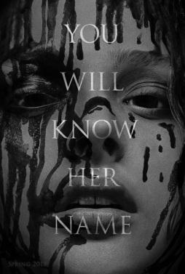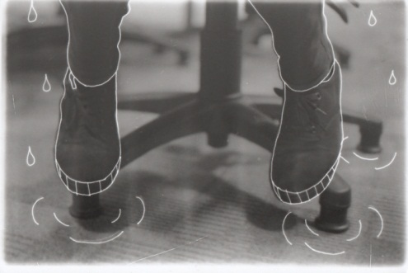

RUBRIC
Student Name:
Criteria:
Level R = none-insufficient Level 1 = limited Level 2 = somewhat Level 3 = considerably Level 4 = thoroughly
(50 - 59%) (60 - 69%) (70 - 79%) (80 - 100%)

Knowledge and Understanding (Understanding of concepts, elements, principles, meaning and significance)
• Demonstrates an understanding of developer painting  • Demonstrates an understanding of silhouette blocking  • Demonstrates an understanding of negative distressing  • Demonstrates an understanding of photogram and photo enlarging  • Demonstrates an understanding of Word and/or image Superimposition  • Demonstrates an understanding of negative enlarging  • Demonstrates an understanding of paper development | R 1 2 3 4  R 1 2 3 4  R 1 2 3 4  R 1 2 3 4  R 1 2 3 4  R 1 2 3 4  R 1 2 3 4 | overall mark for category:  /70

Thinking and Inquiry (Planning & Process; Creative thinking skills & processes, critical analysis)
Planning & Process  • evidence of thorough proposal/rough drafts/ preliminary planning, documented (in sketchbook)  *two superimposed images  • effective teacher-conferencing in a timely manner  • your work was prepared on time for class critiques, peer feedback  Problem Solving  • The problem of creating successful arrangements/compositions  • The problem of silhouette blocking  • The problem of effective distressing  • The problem of choosing objects of various opacities  • The problem of combining words or drawn images to a photo  • The problem of exposing your paper to the correct amount of light (text strip)  • The problem of developing the photo on your paper | R 1 2 3 4  R 1 2 3 4  R 1 2 3 4  R 1 2 3 4  R 1 2 3 4  R 1 2 3 4  R 1 2 3 4  R 1 2 3 4  R 1 2 3 4  R 1 2 3 4 | overall mark for category:  /100

Communication (The conveying of meaning through various forms; communication of intended message expression/organization of ideas)
The completed rubric answers:  • The rubric questions have been thoroughly answered and were properly submitted with your completed assignment and answers demonstrate attention to details and thoughtful, insightful answers.  • Developer Painting is strategic and relates strongly in a thematic way to the original image, or creates an entirely new perspective on it  • Silhouette Blocking is strategic and relates strongly in a thematic way to the original image, or creates an entirely new perspective on it  • Distress added to negatives is strategic and relates strongly in a thematic way to the original image, or creates an entirely new perspective on it  • photogram objects added are strategic and relate strongly in a thematic way to the original image, or creates an entirely new perspective on it  • Word and/or image additions are strategic and relates strongly in a thematic way to the original image, or creates an entirely new perspective on it | R 1 2 3 4  R 1 2 3 4  R 1 2 3 4  R 1 2 3 4  R 1 2 3 4  R 1 2 3 4 | overall mark for category:  /70

Application (The use and knowledge to make connections within and between various contexts; final product, composition, creativity)
Foundations: Responsible Practices.  • throughout the creation of this piece you demonstrated responsible studio practice by: Maintaining a clean, respectful workspace; Consistent, proper, safe materials usage; Not wasting/losing materials/tools/equipment; Responsible, ethical digital citizenship.  Application:  • Final Arrangement of developer painting is interesting, creative and unique  • Final Arrangement of silhouette blocking is interesting, creative and unique  • Final Arrangement of distressed negative is interesting, creative and unique  • Final Arrangement of photogram combination is interesting, creative and unique  • Final Arrangement of word and/or image addition is interesting, creative and unique  • Paper development is balanced and effective  • Final prints are clean, professional and nicely mounted (free of wrinkles, fingerprints, etc.) | R 1 2 3 4  R 1 2 3 4  R 1 2 3 4  R 1 2 3 4  R 1 2 3 4  R 1 2 3 4  R 1 2 3 4  R 1 2 3 4 | overall mark for category:  /80

Rubric Questions:

*To be typed or written on a separate sheet.
Each question should be a full paragraph (minimum 5 sentences each)
- For each photo, create a paragraph describing your artistic vision and methods in accomplishing them.
- Give your pieces a title. What are the titles and why did you choose them?

