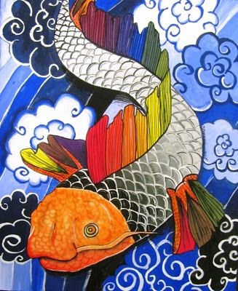
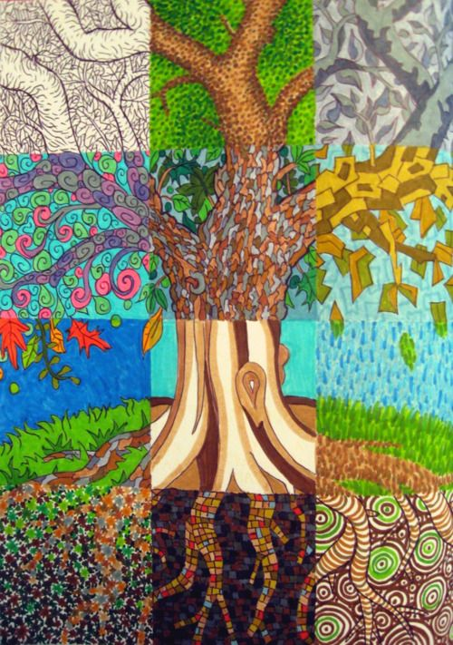
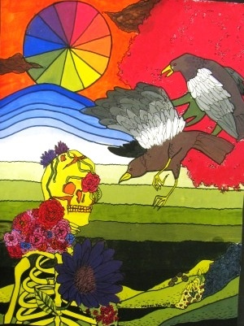
Colour Theory Painting
- Find or plan at least one central imaged/subject.
- Find or plan one background.
- Sketch 3 options for final compositions, planning out an effective layout:
- Fill the Frame
- Rule of Odds
- Rule of Thirds
- Leading Lines
- Varying your Sizes
- Mergers
- Redraw the image(s) and your background onto your “canvas”.
- Segment your piece into block areas that suit your objects/backgrounds. Each will be painted with a different colour scheme:
- Grey scale
- Colour Value Scale
- Warm Colours
- Cool Colours
- Complementary Colours
- Analogous Colours
* on the sketch you choose, pre-plan and label these blocks
6. Paint your entire piece, leaving no blank
paper. Pay close attention to precision
when you paint.
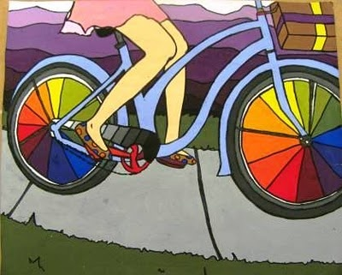

RUBRIC – Colour Theory Painting Student Name:

Criteria:
Level R = none-insufficient Level 1 = limited Level 2 = somewhat Level 3 = considerably Level 4 = thoroughly
(50 - 59%) (60 - 69%) (70 - 79%) (80 - 100%)

Knowledge and Understanding (Understanding of concepts, elements, principles, meaning and significance)
• Demonstrates an understanding rules of composition  • Demonstrates an understanding colour theory and schemes | R 1 2 3 4  R 1 2 3 4 | overall mark for category:  /20

Thinking and Inquiry (Planning & Process; Creative thinking skills & processes, critical analysis)
Planning & Process  • colour painting sheets and layout sketches  Subjects and Composition  • Division of subjects and backgrounds is creative and suitable to theme  • Chosen subject and background are suitable to the assignment | R 1 2 3 4  R 1 2 3 4  R 1 2 3 4 | overall mark for category:  /30

Communication (The conveying of meaning through various forms; communication of intended message expression/organization of ideas)
The completed rubric answers:  • The rubric questions have been thoroughly answered and were properly submitted with your completed assignment.  • The rubric answers demonstrate attention to details and thoughtful, insightful answers.  Subjects and Composition  • Chosen subject and background are unique, interesting, and well suited to each other | R 1 2 3 4  R 1 2 3 4  R 1 2 3 4 | overall mark for category:  /30

Application (The use and knowledge to make connections within and between various contexts; final product, composition, creativity)
Foundations: Responsible Practices.  • Throughout the creation of this piece you demonstrated responsible studio practice by: Maintaining a clean, respectful workspace; Consistent, proper, safe materials usage; Not wasting/losing materials/tools/equipment; Responsible, ethical digital citizenship.  Application:  • Professional presentation of the final product (clean, unwrinkled paper)  • Painting technique demonstrates precision  • Full spectrum of value scales are created through painting  (lightest lights and darkest darks)  • Composition is interesting and follows rules of composition well  • Paint mixing effectively creates colour schemes intended | R 1 2 3 4  R 1 2 3 4  R 1 2 3 4  R 1 2 3 4  R 1 2 3 4  R 1 2 3 4 | overall mark for category:  /60
RUBRIC QUESTIONS: * Answer these questions on a different piece of paper to allow yourself space to fully discuss. Provide a full paragraph for each answer (a minimum of 5 sentences).
- Describe the images you chose for you subject and background and why they are effective to the project.
- What rules of Composition did you apply and how did they help create an effective layout.
- Describe your painting process. What did you find easy, challenging, etc. Describe your strengths and weaknesses and how you overcame them
- Are you pleased with the overall product? Why or why not?

