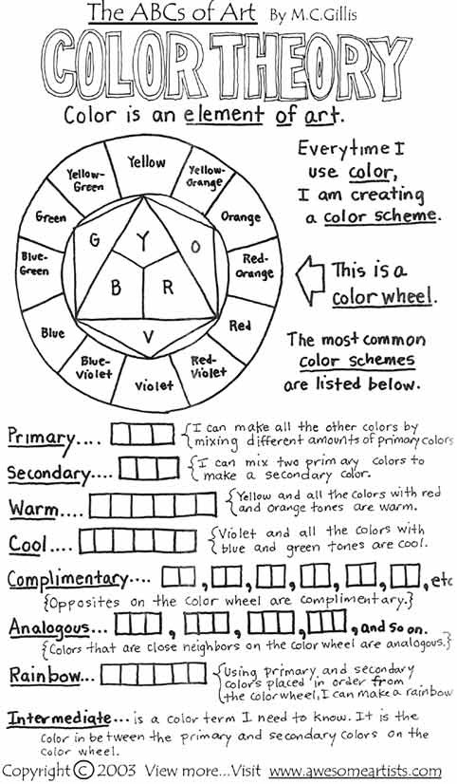
Colour in the wheel and boxes using pencil crayons
Colour Theory – Part One
THE COLOUR WHEEL – REVIEW FROM MEMORY!
The three primary colours are: ______________, _________________ and __________________.
You can not create these colours by mixing any others. Every other colour can be created by mixing these three.
The three secondary colours are _______________, _____________ and __________________.
Red + Blue = __________________
Blue + Yellow = _______________
Red + Yellow = ___________________
The six tertiary colours are:
_________________________________ _________________________________
_________________________________ _________________________________
_________________________________ _________________________________
Practice mixing colours by painting in the colour wheel below. Label each colour with the appropriate name:
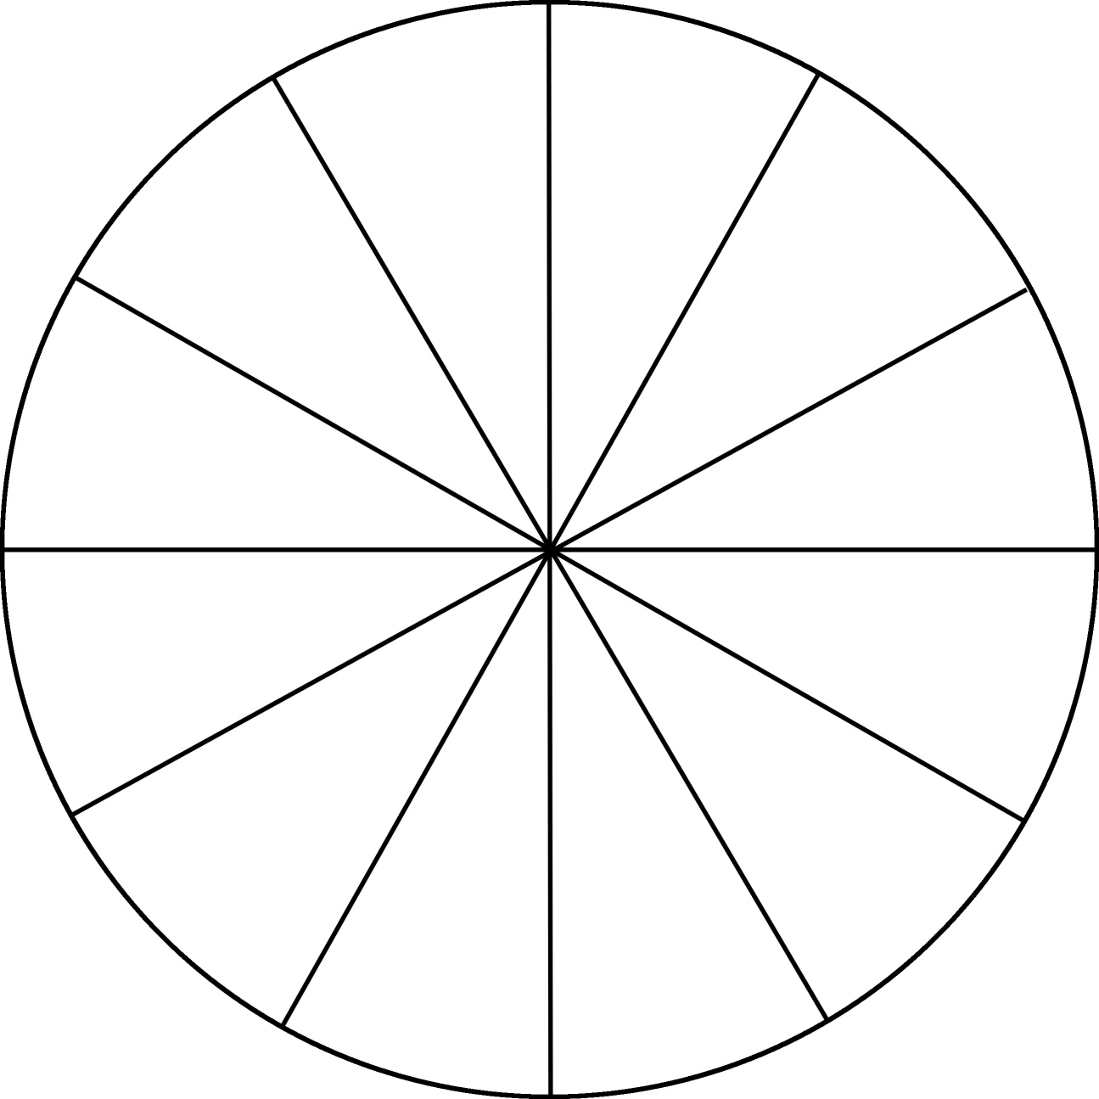
Mixing Complementary Colours
 | + |  | =
 | + |  | =
 | + |  | =

Paint the following Colour Schemes
WARM
COOL
COMPLEMENTARY
ANALAGOUS

HUE – another word for Colour. There are countless hues.
Try naming as many as you can:

TINT – Also known as Pastel is created by adding white to any colour and lightening its value.
Use a smaller amount of colour, and a larger amount of white.
A color scheme using Tints is usually soft, youthful and soothing.
SHADE - A Shade is simply any color with black added.
Most artists use black sparingly because it can quickly destroy your main color.
Shades are deep, powerful and mysterious.

On the following sheet, paint the true hue in the center, then create a value scale from darkest on the left to lightest on the right.

TINT and SHADE Practice - Painting
RED
BLUE
YELLOW
GREEN
PURPLE
ORANGE

