CLAY TERMINOLOGY

RAW CLAY
- a stiff, sticky fine-grained __________, typically yellow, red, or bluish-gray in color and often forming an __________ layer in the soil.
- It can be ___________ when _______, and is ________ and ________ to make bricks, ________, and __________.
POTTERY
- _______, dishes, and other articles made of ___________ or baked ________.
TOOLS (label the following)
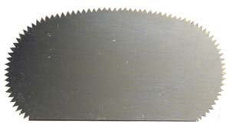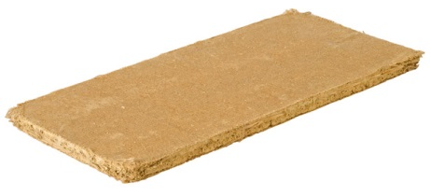

SLIP
Bits of ______ clay mixed with ______ to create the “_______” to stick slabs or coils together

KNEADING/WEDGING
- Working your clay by _____, turning and ________
- _________ clay and eliminates air _________

ROLLING
- Using a rolling pin, and levelers, roll out _______ of clay
- Used to create slabs

SLAB
- A uniformly _____ section of clay that has been rolled
- Used to create your ___ or a large ______ of surface

COILING METHOD
- ________ and _____ between your base ______ and each _______
- Coils are _______ upon each other to build up the ______ of your vessel.
- Coils build more _______ vs a slab

SCORE
- ______ lines into your clay to create _______ where the ______ will sit to “_______” pieces of clay _______

SCORE AND SLIP
- Score and slip ____ sides of the surface to _____ them together

DAMPEN
- _____ your clay in ______ paper towels and ______ between work sessions to keep it _______

DRY
- When completely finished, leave your piece out in the ___ to _______ out
- Ensure the piece is ______ dried for ______ days

KILN FIRE
- _______ off your clay in the ______ to _______ it

PAINT
- You can paint the ______ of your baked clay for __________

GLAZE
- Glaze is a layer or _______ of a vitreous (______/paint) substance which has been _______ to a ceramic object through firing. Glaze can serve to ______, decorate, strengthen or __________ an item

