Clay Busts
CURRICULUM EXPECTATIONS
A1. The Creative Process: apply the creative process to the positioning and painting of their bust;
A2. The Elements and Principles of Design: apply colour, balance, form, texture to create to create your bust for the purpose of self-expression and to communicate ideas
A3. Production and Presentation: produce clay bust
B1. The Critical Analysis Process: demonstrate an understanding of the critical analysis process by examining, interpreting, evaluating, and reflecting on your bust
C1. Terminology: demonstrate an understanding of, and use correct terminology when referring to, elements, principles, and other components related to your bust
C2. Conventions and Techniques: demonstrate an understanding of conventions and techniques used in the creation of your bust
C3. Responsible Practices: demonstrate an understanding of responsible practices related to visual arts.

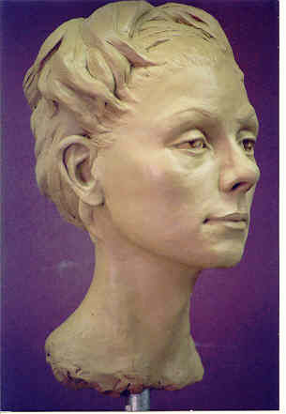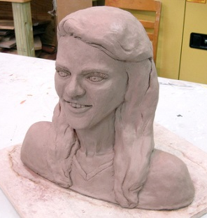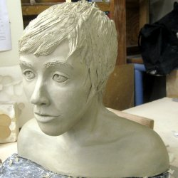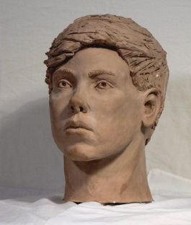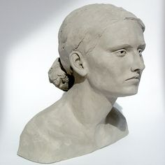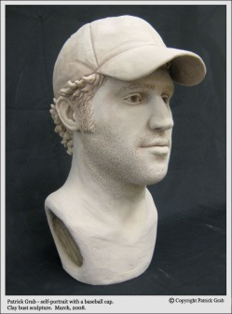
Students will plan and create a clay bust in the likeness of one of their classmates.

Step 1: measure their classmate using the calipers
Step 2: create an armature
Step 3: sculpt the bust
Step 4: Remove the bust from the armature and reassemble it
Step 5: fire the bust
Step 6: apply a paint or glaze to your bust

RUBRIC Bust Student Name:
Criteria:
Level R = none-insufficient Level 1 = limited Level 2 = somewhat Level 3 = considerably Level 4 = thoroughly
(50 - 59%) (60 - 69%) (70 - 79%) (80 - 100%)
Knowledge and Understanding (Understanding of concepts, elements, principles, meaning and significance)
• Demonstrates an understanding of proportions (overall, facial, and 3dimenstionally)  • Demonstrates an understanding of clay properties and proper use of the material  • Demonstrates an understanding of measurements (use of calipers)  • Demonstrates an understanding of creation of armature  • Demonstrates an understanding of painting/glazing  • Demonstrates an understanding of facial features  • Demonstrates an understanding of surface texture  • Demonstrates an understanding of structural balance | R 1 2 3 4  R 1 2 3 4  R 1 2 3 4  R 1 2 3 4  R 1 2 3 4  R 1 2 3 4  R 1 2 3 4  R 1 2 3 4 | overall mark for category:  /80

Thinking and Inquiry (Planning & Process; Creative thinking skills & processes, critical analysis)
Planning & Process  • Measurements and drawings are thoroughly completed  • Adjustments are made throughout process to correct issues  • Assignment is submitted on time | R 1 2 3 4  R 1 2 3 4  R 1 2 3 4 | overall mark for category:  /30

Communication (The conveying of meaning through various forms; communication of intended message expression/organization of ideas)
The completed rubric answers:  • The rubric questions have been thoroughly answered and were properly submitted with your completed assignment and demonstrate attention to details and thoughtful, insightful answers. | R 1 2 3 4 | overall mark for category:  /10

Application (The use and knowledge to make connections within and between various contexts; final product, composition, creativity)
Foundations: Responsible Practices.  • throughout the creation of this piece you demonstrated responsible studio practice by: Maintaining a clean, respectful workspace; Consistent, proper, safe materials usage; Not wasting/losing materials/tools/equipment; Responsible, ethical digital citizenship.  Application:  • Professional presentation of the final products (clay)  • True Likeness to subject  • Professional presentation of the final products (paint/patina/glaze)  • Proportions are accurate (overall, facial, and 3dimenstionally)  • Facial features are detailed and realistic  • Balance is functional (bust stands on its own)  • Different parts of Bust explore and utilize appropriate surface Textures  • Bust Fired Successfully (no explosions, crack, dismemberments…) | R 1 2 3 4  R 1 2 3 4  R 1 2 3 4  R 1 2 3 4  R 1 2 3 4  R 1 2 3 4  R 1 2 3 4  R 1 2 3 4  R 1 2 3 4 | overall mark for category:  /90
RUBRIC QUESTIONS: * Answer these questions on a different piece of paper to allow yourself space to fully discuss. (minimum 5 sentences each)
- What do you feel is successful about your final piece? What would you do differently next time to improve it?
- What were the most challenging portions of this assignment? How did you overcome them?

