Aperture and Shutter Speed Experimentation Project

Curriculum Expectations
A1. The Creative Process: apply the creative process to create interesting photos
A2. The Elements and Principles of Design: apply space, balance and rhythm to create photos
A3. Production and Presentation: produce photos using Film SLR camera
B1. The Critical Analysis Process: demonstrate an understanding of the critical analysis process by examining, interpreting, evaluating, and reflecting on your photos
C1. Terminology: demonstrate an understanding of, and use correct terminology when referring to, elements, principles, and other components related to photos
C2. Conventions and Techniques: demonstrate an understanding of SLR settings used in the creation of photos
C3. Responsible Practices: demonstrate an understanding of responsible practices related to visual arts.

PART ONE: For this section you will take FOUR photos capturing movement:
- 2 Freeze frame (of 2 different subjects)
- 2 Blurred motion (of 2 different subjects)
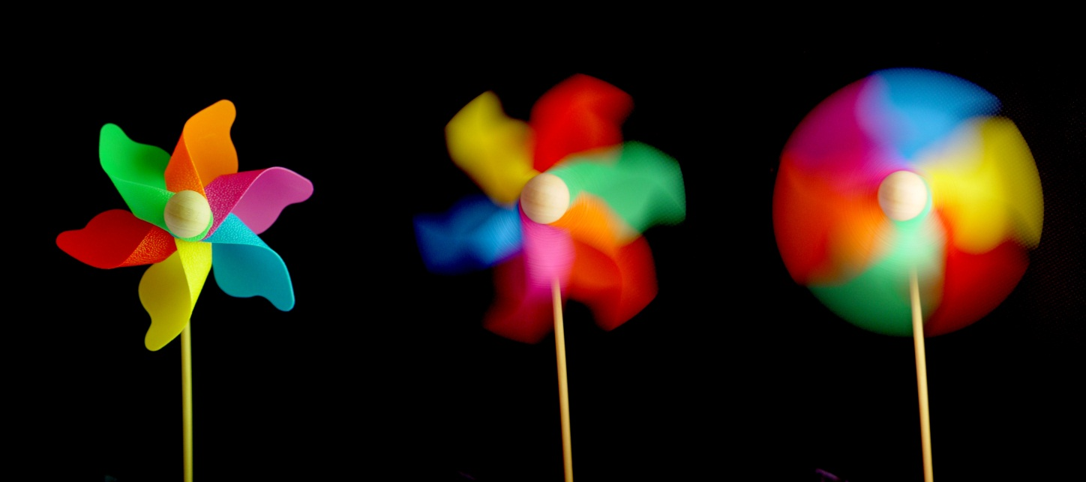

PART TWO: For this section you will take FOUR photos capturing two different Depths of Field.
- Blurred background (of 2 different subjects)
- Full focus (of 2 different subjects)

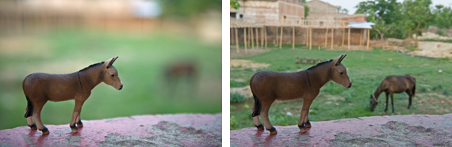

Process:

- Plan your photos using the planning charts provided – use different settings for each photo (aperture and f/stop) to see what works best. Use the online tool to plan accurate settings for your captures:
http://camerasim.com/apps/camera-simulator/
- Draw thumbnail sketches of the photos you will take, considering elements of a good composition.
- Go out as a team and capture your photos. Use the Film Tracking Sheet to keep track of what photos on the roll belong to each member of your group.

RUBRIC
Student Name:
Criteria:
Level R = none-insufficient Level 1 = limited Level 2 = somewhat Level 3 = considerably Level 4 = thoroughly
(50 - 59%) (60 - 69%) (70 - 79%) (80 - 100%)

Knowledge and Understanding (Understanding of concepts, elements, principles, meaning and significance)
• Demonstrates an understanding of Depth of Field (viewed on planning sheets)  • Demonstrates an understanding of Capturing Movement (descriptions) | R 1 2 3 4  R 1 2 3 4 | overall mark for category:  /20

Thinking and Inquiry (Planning & Process; Creative thinking skills & processes, critical analysis)
Planning & Process  • evidence of thorough proposal/rough drafts/ preliminary planning, documented on rough planning sheets provided  • effective teacher-conferencing in a timely manner  Problem Solving  • The problem of utilizing various F-Stops and Apertures (different settings each time) | R 1 2 3 4  R 1 2 3 4  R 1 2 3 4 | overall mark for category:  /30

Communication (The conveying of meaning through various forms; communication of intended message expression/organization of ideas)
The completed rubric answers:  • The rubric questions have been thoroughly answered and were properly submitted with your completed assignment and demonstrate attention to details and thoughtful, insightful answers.  • A variety of subjects were captured that worked well for the intended shot (4) | R 1 2 3 4  R 1 2 3 4 | overall mark for category:  /20

Application (The use and knowledge to make connections within and between various contexts; final product, composition, creativity)
Foundations: Responsible Practices.  • throughout the creation of this piece you demonstrated responsible studio practice by: Maintaining a clean, respectful workspace; Consistent, proper, safe materials usage; Not wasting/losing materials/tools/equipment; Responsible, ethical digital citizenship.  Application:  • Final Freeze frame captures motion crisply  • Final Motion blur clearly depicts the movement of motion  • Final Narrow Depth of Field effectively focuses on one are of your image  • Final Wide Depth of Field effectively focuses on the entire frame of your image | R 1 2 3 4  R 1 2 3 4  R 1 2 3 4  R 1 2 3 4  R 1 2 3 4 | overall mark for category:  /50

Rubric Questions:

*To be typed or written on a separate sheet. Each question should be a full paragraph
(minimum 5 sentences each)
- What have you learned about Shutter Speed and Aperture?
- What did you find the most challenging about this project
- What area do you still need to work on improving?

PART ONE:
 | ISO | Aperture |  | Shutter Speed
1
2
 | Subject and photo description s
Freeze Frame photo #1
Thumbnails

Freeze Frame photo #2

 | ISO | Aperture |  | Shutter Speed
1
2
 | Subject and photo description
Thumbnails

PART TWO:
 | ISO | Aperture |  | Shutter Speed
1
2
 | Subject and photo description
Narrow Depth of Field
Thumbnails

Wide Depth of Field

 | ISO | Aperture |  | Shutter Speed
1
2
 | Subject and photo description
Thumbnails

