An Introduction to Science Fiction
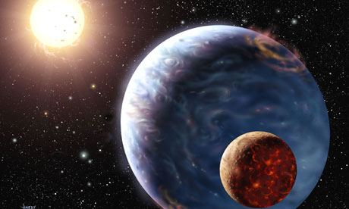
When you hear the words ‘Science Fiction’, what three things immediately come to mind?

When thinking of the media and popular culture (movies, TV shows, websites, games, documentaries etc.), what comes to mind in the form of science fiction?
_______________________________________________________________________________________________________________________________________________________________________________________________________________________________________________________________

Have you ever read a science fiction novel before? YES or NO

If so, what was the book title and who was the author? _______________________________________

Compare and contrast Science Fiction vs. Fantasy. What are the differences and similarities?

In your own words, write a definition for the Science Fiction genre:
____________________________________________________________________________________________________________________________________________________________________________________________________________________________________________________________________________________________________________________________________________________

After discussing the definition with your class, write a revised copy of the definition:
_________________________________________________________________________________________________________________________________________________________________________________________________________________________________________________________________________________________________________________________________________________________________________________________________________________________________________

