|  |
| --- |
| **ALC1OIPY - ADOBE PHOTOSHOP BASICS** |

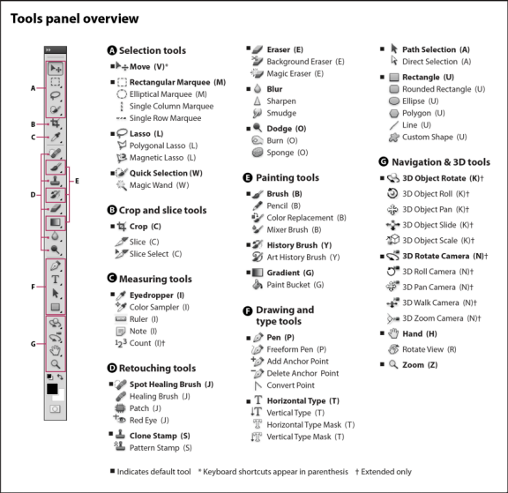

**WHAT IS PHOTOSHOP?**

🞟 Image __________ __________

🞟 Shows images as ___________

🞟 Bitmap = arrangement of _____

on a grid

🞟 Pixels = smallest _______ of an image

🞟 End product/result can be saved in a variety of ways: ._____, ._____, .______, .______, .____ , ._______

**THE TOOLBOX**

|  |  |
| --- | --- |
| ***Move Tool*** | Lets you ____________ a selection marquee or ___________ on a single layer. |
| ***Marquee Tools*** | Allows you to _______________ rectangular or elliptical areas in an image. |
| ***Lasso Tools*** | Lets you _______________ selection area, with either curves or straight lines. |
| ***Magic Wand*** | Allows you to select all the ______________ or similarly colored adjacent pixels |
| ***Crop/Slice Tools*** | Allows you to _________ the image |
| ***Eyedropper Tool*** | Allows you to ________ a __________ from an image to use this colour further. |
| ***Spot Healing Brush*** | R___________ blemishes, imperfections, and ___________ ___________. |
| ***Brush Tool*** | P_____________ brush strokes. |
| ***Gradient Tool*** | Helps you to ___________ stage by stage with more than _______________. |
| ***Paint Bucket Tool*** | F___________ out a cropped part with just _______ click |
| ***Eraser Tool*** | E_________ what you cropped or where you _________ with your mouse after selecting this tool |
| ***Smudge Tool*** | Has the same effect as ______________canvas with fingers |
| ***Dodge Tool*** | Makes ____________ the part where you scrub with this tool. |
| ***Clone Stamp*** | C_________ a selected part and ____________ it where you want. |
| ***Text Tool*** | Creates _________ or _________ on a photo. |
| ***Zoom Tool*** | M________________ or _______________the size of an image. |
| ***Foreground/***  ***Background*** | Photoshop uses the ***foreground*** *color* to ___________, _______, and ____________ selections and the ***background*** *color* to make ______________ |

**THE MENU**

|  |  |
| --- | --- |
| **File** |  |
| **Edit** |  |
| **Image** |  |
| **Layer** |  |
| **Select** |  |
| **Filter** |  |
| **View** |  |
| **Window** |  |

**PANELS/PALETTES**

**Color Panel:** __________ the color (basically RGB colors) and select it for the f________________ and b________________ colors.



**Swatches Panel:** You can ___________ ____________ among the samples of colours



**Styles Panel:** You can choose a _________ ____________ of colours on the layer you selected, such as texts, buttons, and images



**History Panel:** Photoshop automatically _________ the process of your works. (basically 20 ________ ___________ to the current work)

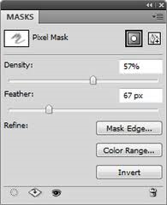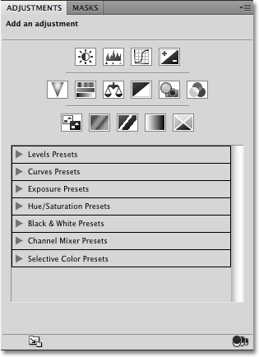

**Adjustments Panel:** allows you to edit colours, ____________, ________, _________, ___________, ___________, ________, channels, mix colors, add gradients, etc.

**Masks Panel:** _____________ all of the tools and _________ you’ll need to customize your Layer Mask in one location



**Layers Panel:** S_____________ each step of your works from others. By making layers and working different steps on each layer, you can make separate effects on each layer.