11 Sketchbook Inspirations
End result, 11 photos inspired by this list of 29 inspirations. Complete them in any order you choose - except #1 must be #1 as it is your first assignment - using the following criteria:
- You must sketch a minimum of 3 photo options before deciding which one to shoot
- The final image must be developed in miniature (or printed in colour) and pasted into your sketchbook
- You must fill out the information sheet data next to the one photo you choose to capture, one for each of your 11 entries in your sketchbook
- You must conference with me prior to taking your final shot to ensure you are meeting the expectations of each “inspiration”
- Each of your photos must be uploaded in the online Facebook group, in the appropriate folder, along with a title for the work and your artistic vision write up.
*each photo you take MUST be a new photo taken specifically for this course. Photos you have taken prior to this course will not be accepted.
For examples of each “inspiration”, see the course website: kbruceweebly.com
- Selfie * must be your first photo *
- High Angle
* Your Sketchbook Inspirations assignment will be marked twice throughout the term: once after your first 6 and once when all 11 are complete.
First 10 Due Date:

Final Completion Due Date:
- Low Angle
- Extreme Close up
- Landscape
- Still Life
- Portrait
- Reflection
- Architecture
- Long Exposure
- Fast/Short Exposure
- Lens Stencil
- Texture
- Asymmetrical
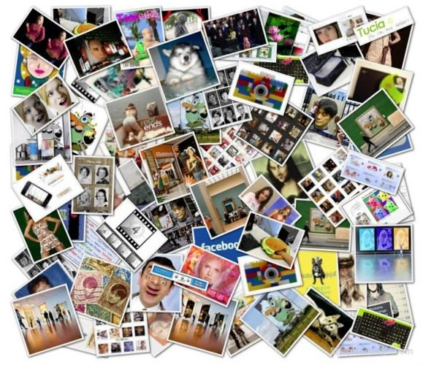
- Shadow
- Contrast
- Colour
- False Perspective
- Symmetrical
- Family
- Food
- World Issue
- Weather
- Nostalgia
- Emotion
- Inspiration
- Season(s)
- Animal
- Water
Exemplar: *you may print and past this chart in your sketchbook, or you can just transcribe the information
Sketch Photo
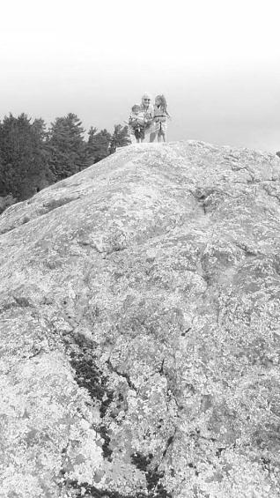
List Number and Name
#3 – Low Angle
Title
Nostalgia
Date
August 28, 2014
Subject(s)
My children and my Uncle
Photo Direction (Vertical/Horizontal)
Vertical
Written Description of Photo, personal connection and Artistic Vision
I plan to take a photo on an island in Stoney Lake, where I grew up as a child. I want to take my children there to experience the beauty and freedom I felt boating and exploring. My uncle made this possible for me then, and now for my children so I would like him in the photo, with my two children, one on each side. The photo will picture the peak of the island, with them perched on top. I would like the rock of the island to be the majority of the photo, but also include some trees and sky. The low angle shot will show my family conquering the top of the island.
Use of Elements and Principles of Design *not simply the one listed, but ensure you include it
E or P | Explanation
Size/Space and Balance  Texture, Contrast and Colour  Line/Focus | I want the majority of the photo to be bottom heavy with the focus on the rock of the island. My intention with this is to minimize the subjects to heighten the power of nature. The subjects are small and insignificant within the landscape. The horizontal balance I prefer to be fairly even, to give a sense of calm and focus directly at the subjects on the top of the island.  The texture of the island is rough and rustic. I want the camera to capture the deep lines in the stone as well as the soft green moss that grows on top as a contrast in texture and colour.  The lines of the treeline, the edges of the island and the cracks in the rock lead your eye directly to the subjects, focussing on their presence.

AWQ 3O - 11 Sketchbook Inspirations

RUBRIC #1 (1st 6 photos) Student Name:

Criteria:
Level R = none-insufficient Level 1 = limited Level 2 = somewhat Level 3 = considerably Level 4 = thoroughly
(50 - 59%) (60 - 69%) (70 - 79%) (80 - 100%)

Knowledge and Understanding (Understanding of concepts, elements, principles, meaning and significance)
• Demonstrates an understanding of the elements and principles of design  • Demonstrates an understanding the key concept of “sketchbook inspiration”  ie what is a low angle shot? | R 1 2 3 4  R 1 2 3 4 | overall mark for category:  /20

Thinking and Inquiry (Planning & Process; Creative thinking skills & processes, critical analysis)
Planning & Process  • evidence of thorough brain–storming, preliminary planning, documented (in sketchbook)  *3 different rough sketches are present for each entry  • A thorough proposal/rough drafts/experiments were submitted and recorded in your sketchbook, and demonstrate thorough exploration of your ideas.  * Chart: Written Description of Photo, personal connection, Artistic Vision and E&Ps  • effective teacher-conferencing in a timely manner  • your work was prepared on time for class critiques, peer feedback  Problem Solving  • The problem of capturing the photo you had originally planned was successful | R 1 2 3 4  R 1 2 3 4  R 1 2 3 4  R 1 2 3 4  R 1 2 3 4 | overall mark for category:  /50

Communication (The conveying of meaning through various forms; communication of intended message expression/organization of ideas)
The completed rubric answers:  • The rubric questions have been thoroughly answered and were properly submitted with your completed assignment and demonstrate attention to details and thoughtful, insightful answers.  The visual communication of the intended message:  • Your artistic vision is clearly communicated in your final photo  Title of work strongly communicates intended meaning | R 1 2 3 4  R 1 2 3 4  R 1 2 3 4 | overall mark for category:  /30

Application (The use and knowledge to make connections within and between various contexts; final product, composition, creativity)
Foundations: Responsible Practices.  • throughout the creation of this piece you demonstrated responsible studio practice by: Maintaining a clean, respectful workspace; Consistent, proper, safe materials usage; Not wasting/losing materials/tools/equipment; Responsible, ethical digital citizenship.  Application:  • Photograph is high quality and in good focus  • Photograph layout is well design using balance, focus, spacing, etc.  • Professional presentation of the final product (printed in sketchbook as well as posted online) | R 1 2 3 4  R 1 2 3 4  R 1 2 3 4  R 1 2 3 4 | overall mark for category:  /40

Rubric Questions:

With which photo do you connect with the most and why?

Which photo do you find the most visually effective/successful and why?

Which photo do you find the least visually effective/successful and why?

Which “inspiration” did you find the easiest and why?

Which “inspiration” did you find the most challenging, and why?

Teacher’s comments & feedback:

AWQ 3O - 11 Sketchbook Inspirations

RUBRIC #2 (2nd 5 photos) Student Name:

Criteria:
Level R = none-insufficient Level 1 = limited Level 2 = somewhat Level 3 = considerably Level 4 = thoroughly
(50 - 59%) (60 - 69%) (70 - 79%) (80 - 100%)

Knowledge and Understanding (Understanding of concepts, elements, principles, meaning and significance)
• Demonstrates an understanding of the elements and principles of design  • Demonstrates an understanding the key concept of “sketchbook inspiration”  ie what is a low angle shot? | R 1 2 3 4  R 1 2 3 4 | overall mark for category:  /20

Thinking and Inquiry (Planning & Process; Creative thinking skills & processes, critical analysis)
Planning & Process  • evidence of thorough brain–storming, preliminary planning, documented (in sketchbook)  *3 different rough sketches are present for each entry  • A thorough proposal/rough drafts/experiments were submitted and recorded in your sketchbook, and demonstrate thorough exploration of your ideas.  * Chart: Written Description of Photo, personal connection, Artistic Vision and E&Ps  • effective teacher-conferencing in a timely manner  • your work was prepared on time for class critiques, peer feedback  Problem Solving  • The problem of capturing the photo you had originally planned was successful | R 1 2 3 4  R 1 2 3 4  R 1 2 3 4  R 1 2 3 4  R 1 2 3 4 | overall mark for category:  /50

Communication (The conveying of meaning through various forms; communication of intended message expression/organization of ideas)
The completed rubric answers:  • The rubric questions have been thoroughly answered and were properly submitted with your completed assignment and demonstrate attention to details and thoughtful, insightful answers.  The visual communication of the intended message:  • Your artistic vision is clearly communicated in your final photo  Title of work strongly communicates intended meaning | R 1 2 3 4  R 1 2 3 4  R 1 2 3 4 | overall mark for category:  /30

Application (The use and knowledge to make connections within and between various contexts; final product, composition, creativity)
Foundations: Responsible Practices.  • throughout the creation of this piece you demonstrated responsible studio practice by: Maintaining a clean, respectful workspace; Consistent, proper, safe materials usage; Not wasting/losing materials/tools/equipment; Responsible, ethical digital citizenship.  Application:  • Photograph is high quality and in good focus  • Photograph layout is well design using balance, focus, spacing, etc.  • Professional presentation of the final product (printed in sketchbook as well as posted online) | R 1 2 3 4  R 1 2 3 4  R 1 2 3 4  R 1 2 3 4 | overall mark for category:  /40

Rubric Questions:

With which photo do you connect with the most and why?

Which photo do you find the most visually effective/successful and why?

Which photo do you find the least visually effective/successful and why?

Which “inspiration” did you find the easiest and why?

Which “inspiration” did you find the most challenging, and why?

Teacher’s comments & feedback:

